Below is an example where you want to pass different types of parameter (say sign up info like first name, last name, mail and phone number) to a condition in a scenario you can pass as below

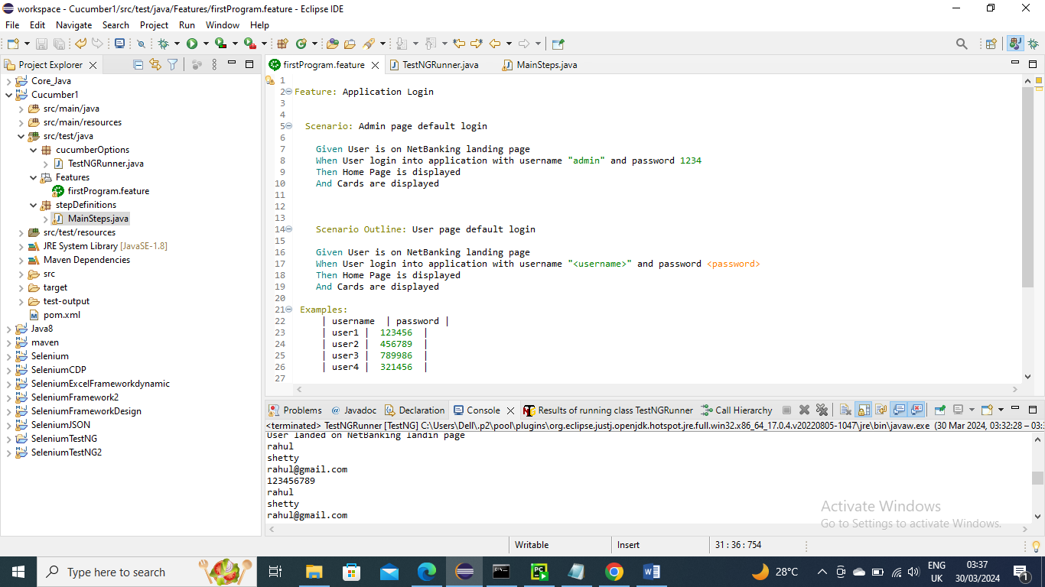

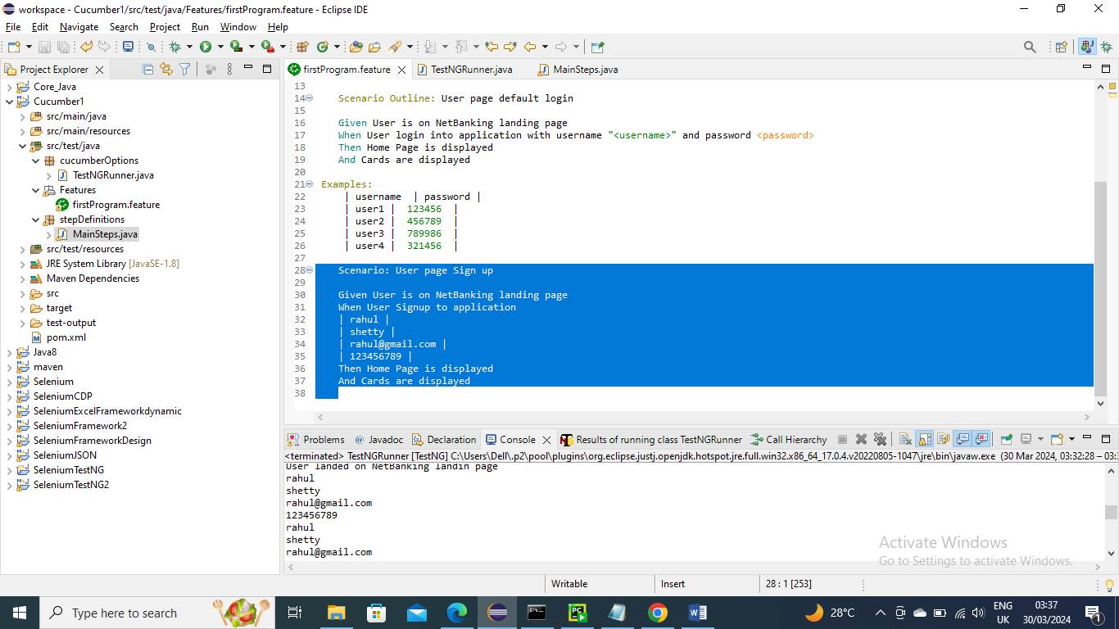

Below is the condition method in stepDefinition to handle that condition

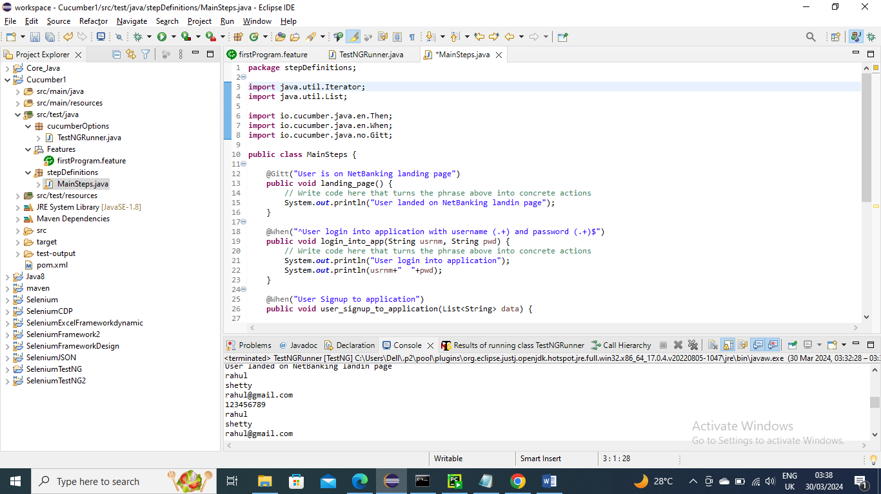

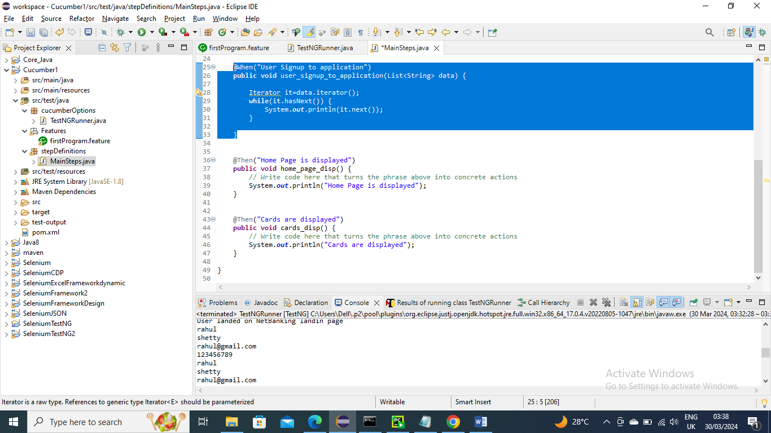

Run the main class as usual

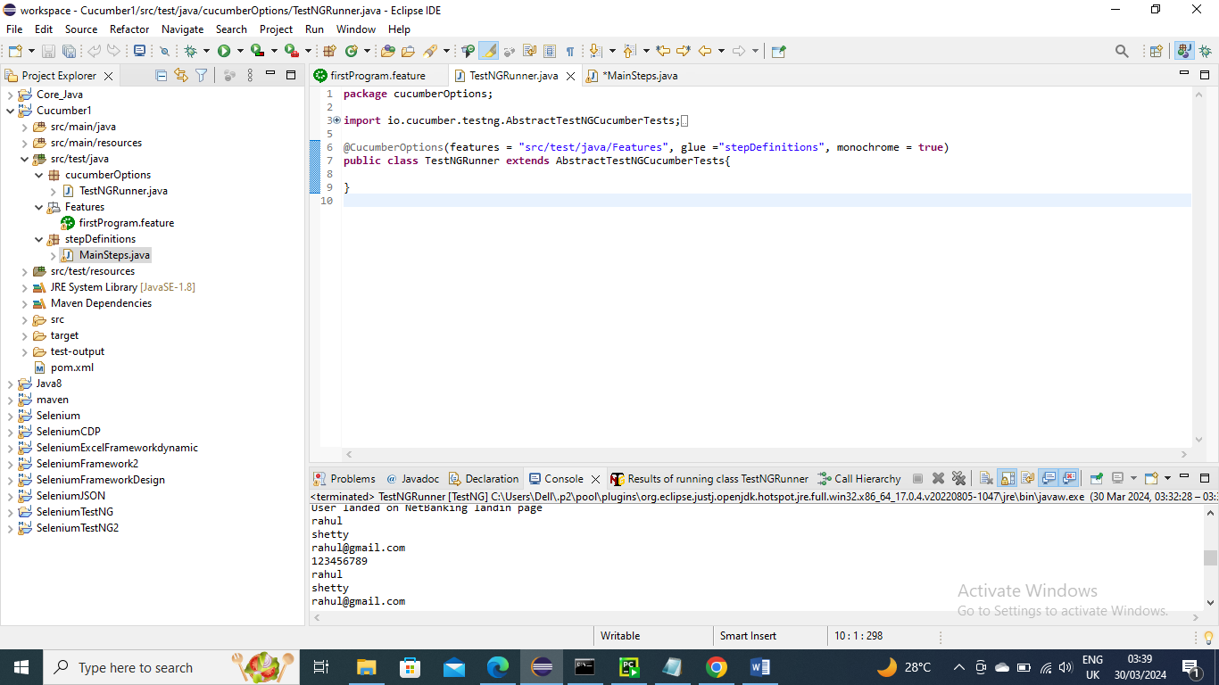

Below is the Output….as you can see the parameters list that sent are handled and printed

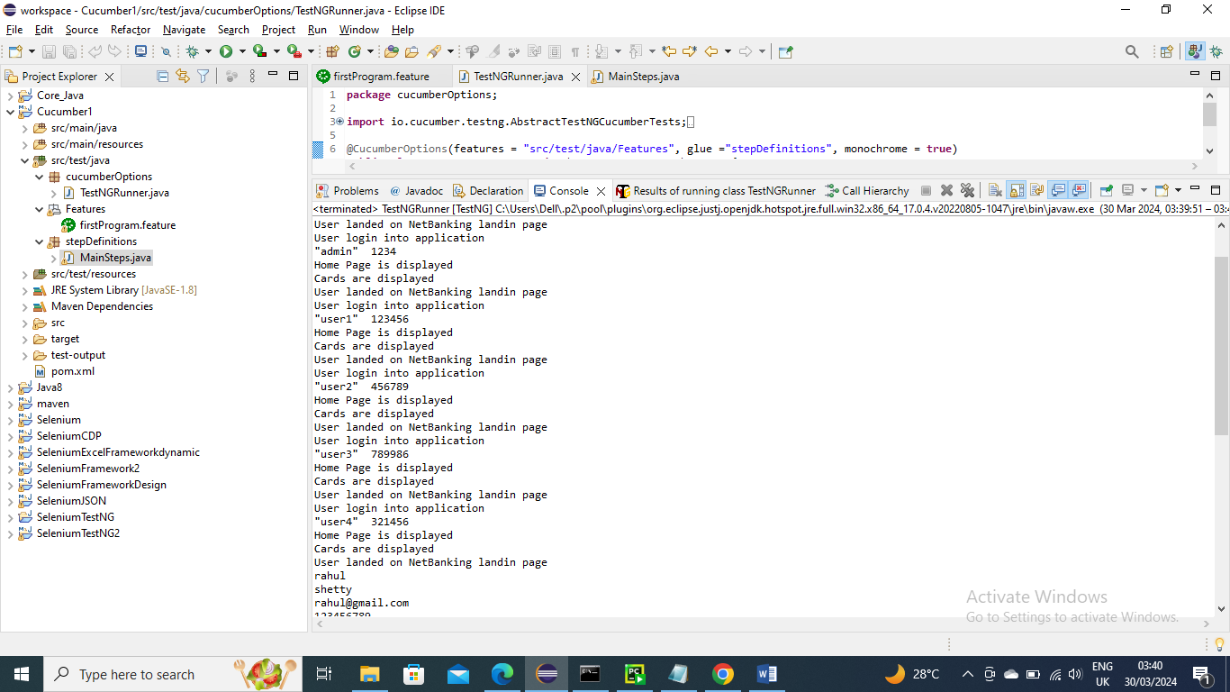

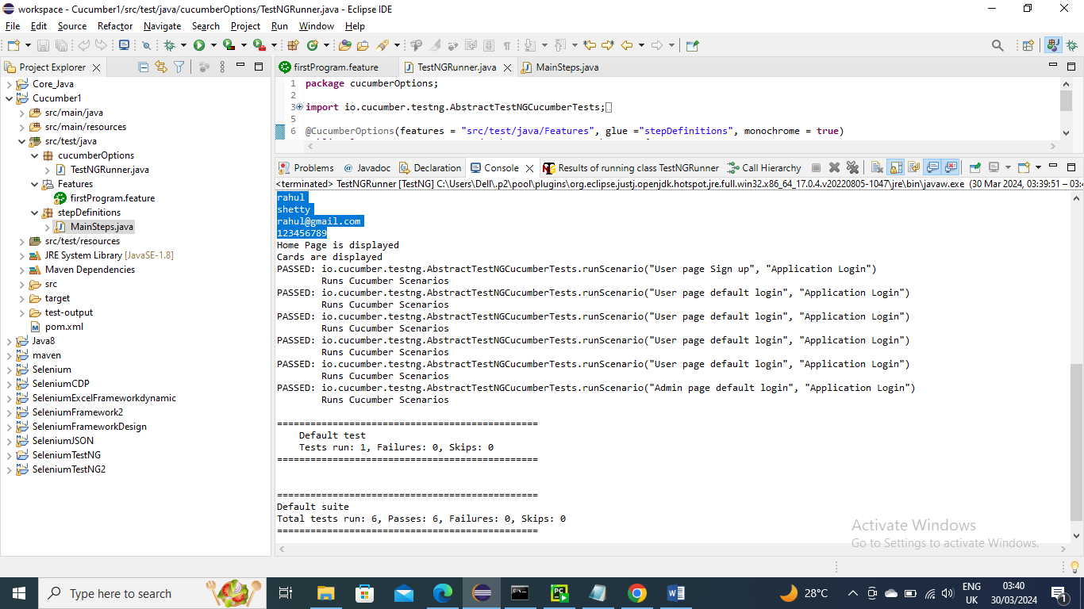

--------------------------------------------

Cucumber tags

Let’s say in a scenario you want to run only particular scenarios then you can tag with @somename and in main class mention that tag =””@somename” so that it will pick only that scenarios

In below I gave @smoketest its not a cucumber keyword or anything you can give any name as you wish

In below I made tag @smoketest to user login and user signup

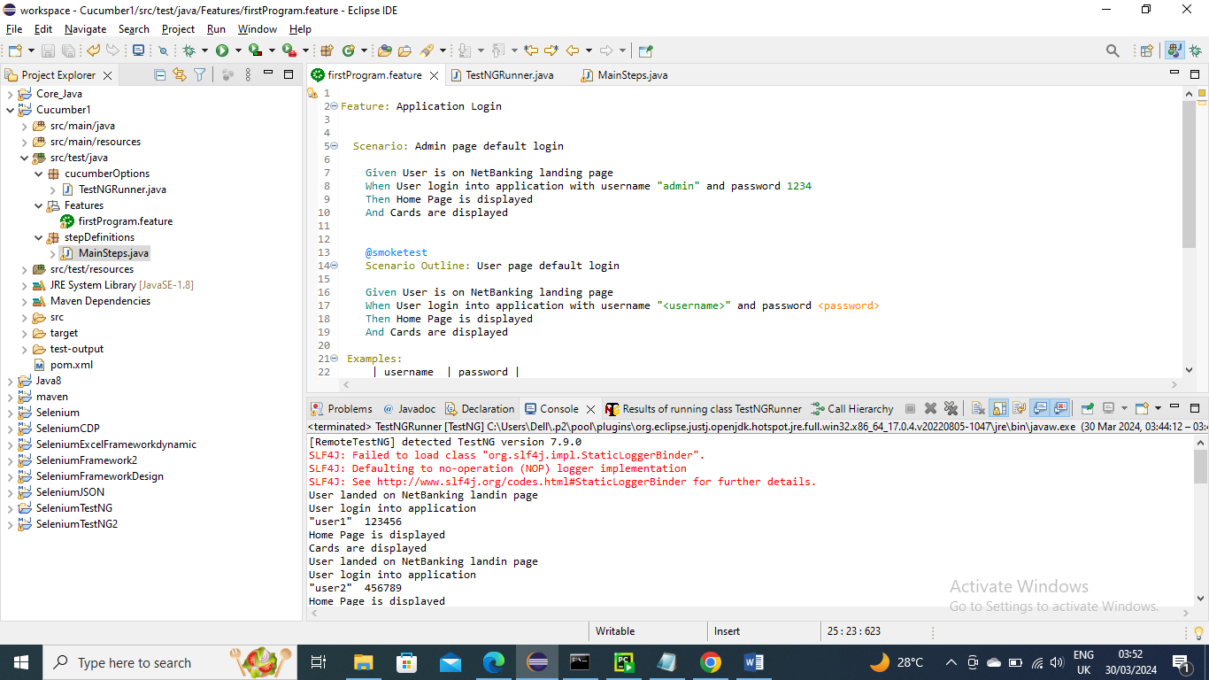

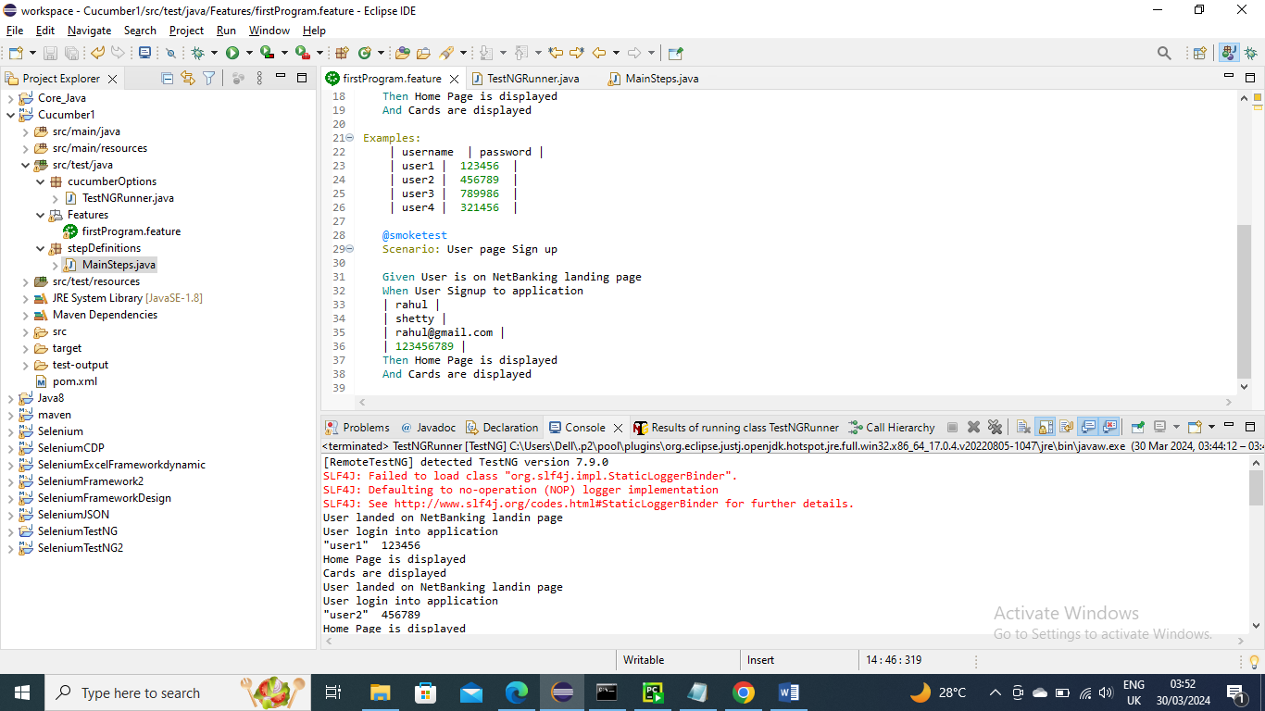

Below is the step definition file

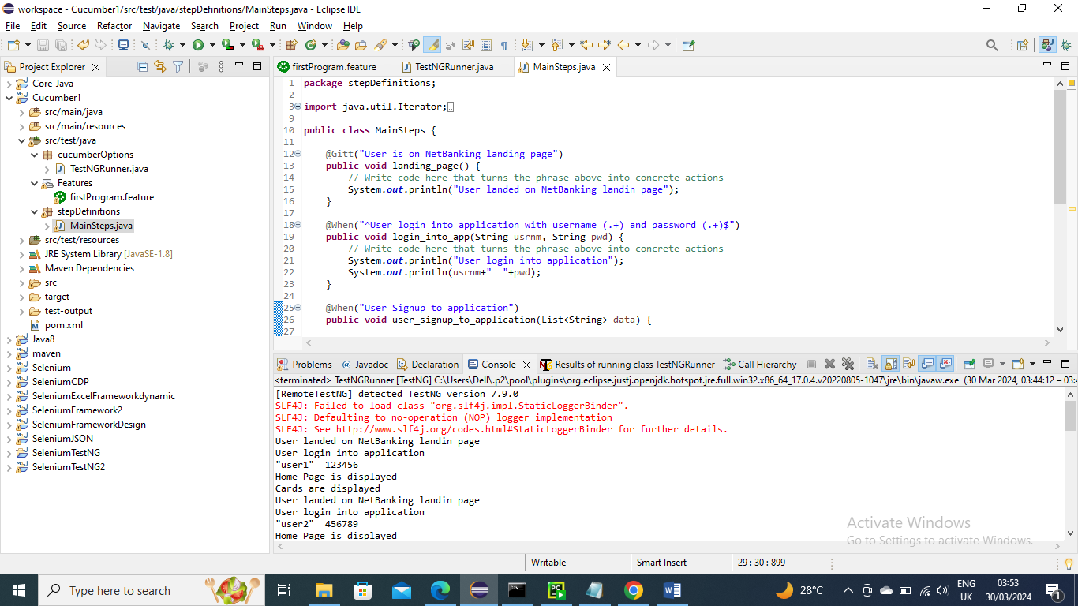

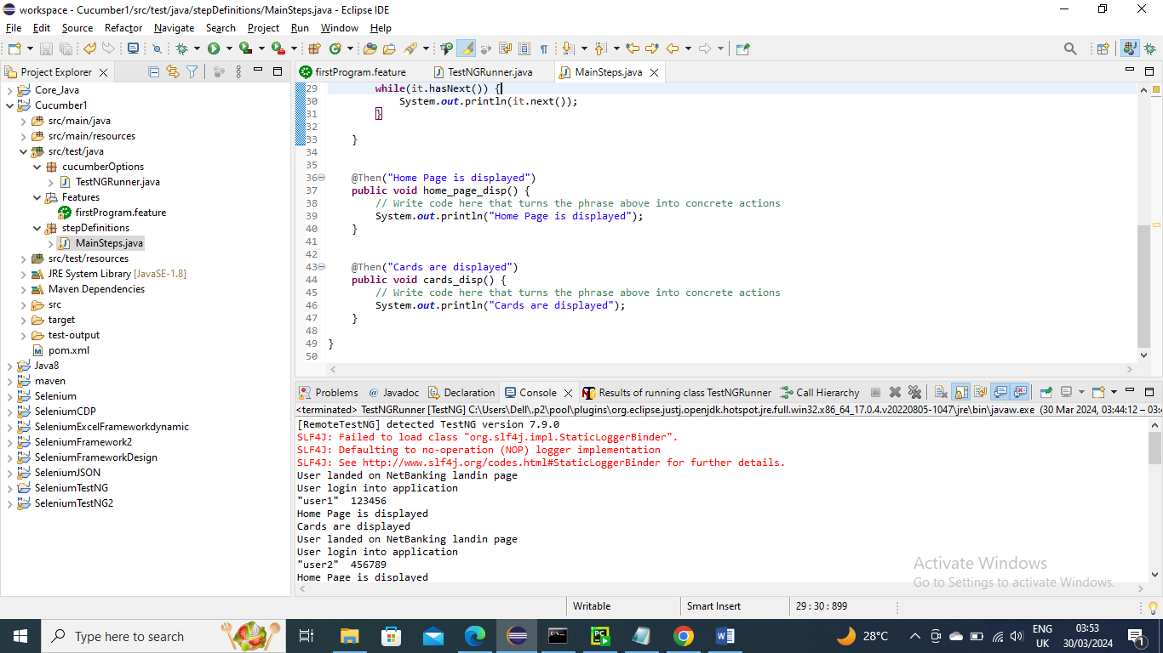

Add the tag name in Main class so that only that scenarios will run and run it

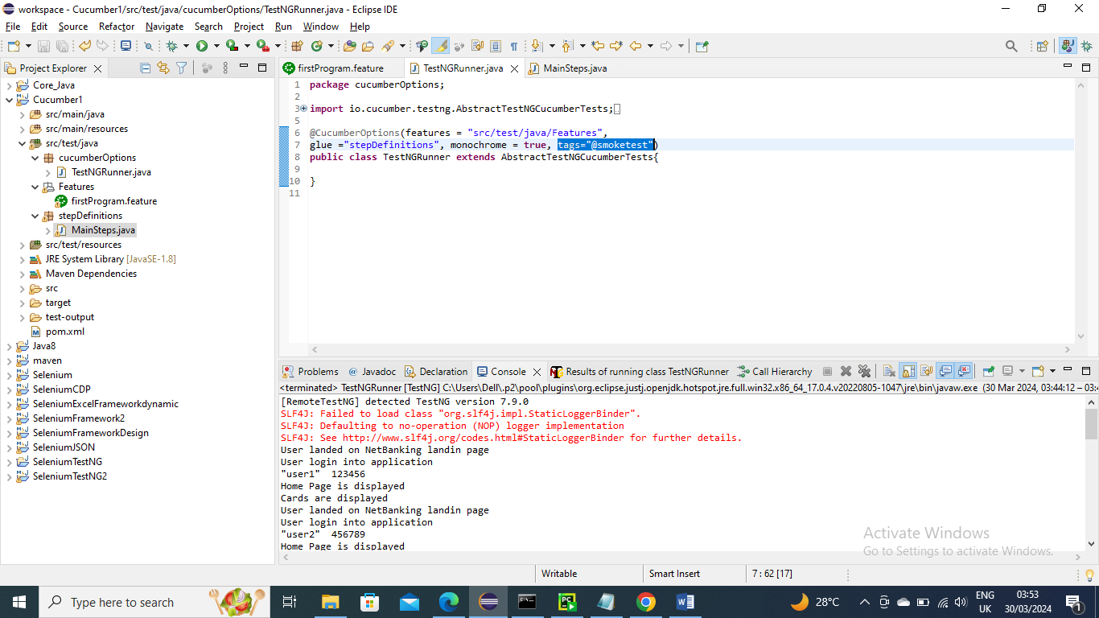

Below is the output……..as expected apart from Admin page other two has run

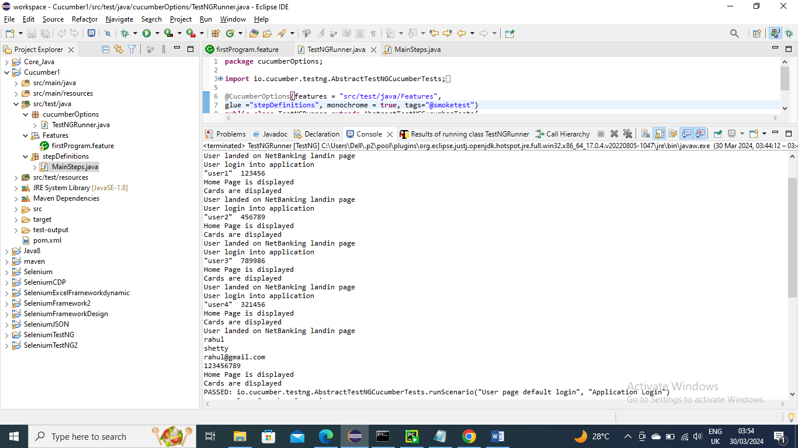

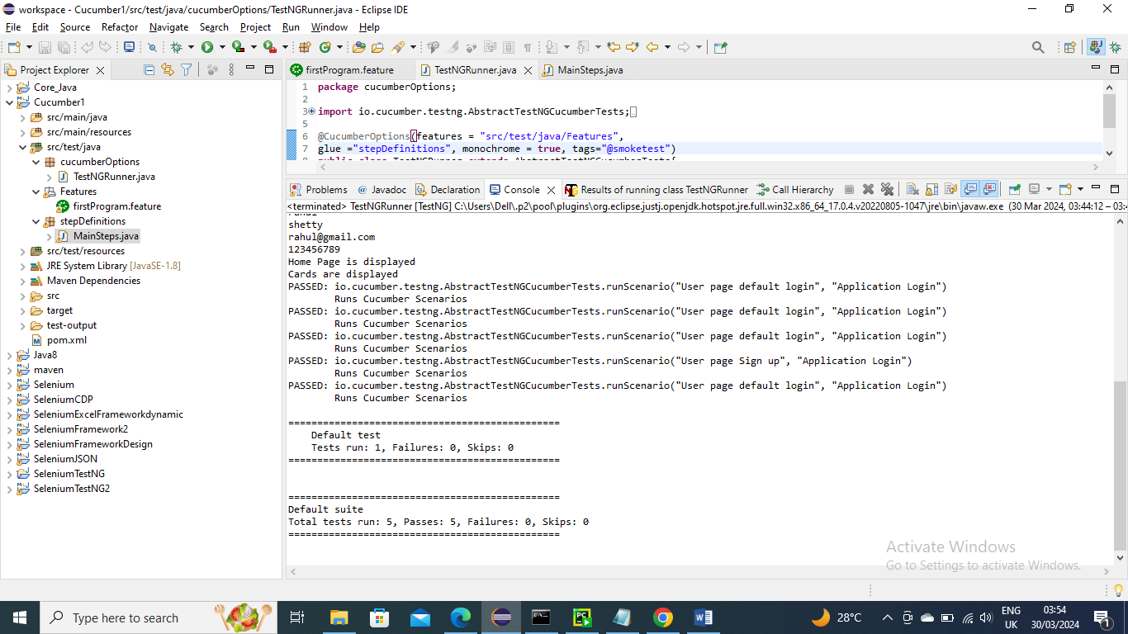

--------------------------------------

Let’s say there are some tags mentioned for some scenarios you wanted to run some particular scenario then for that scenario you can give a tag name and mention that tag in main class and run

Below I made tag for Admin scenario as @regrressiontest

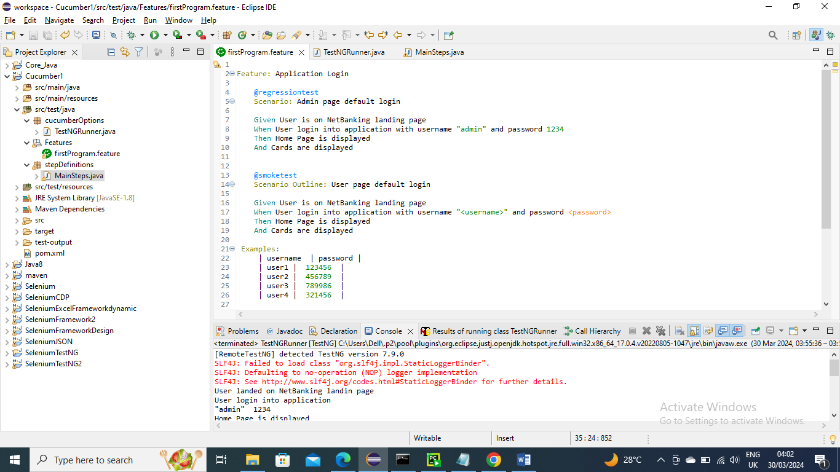

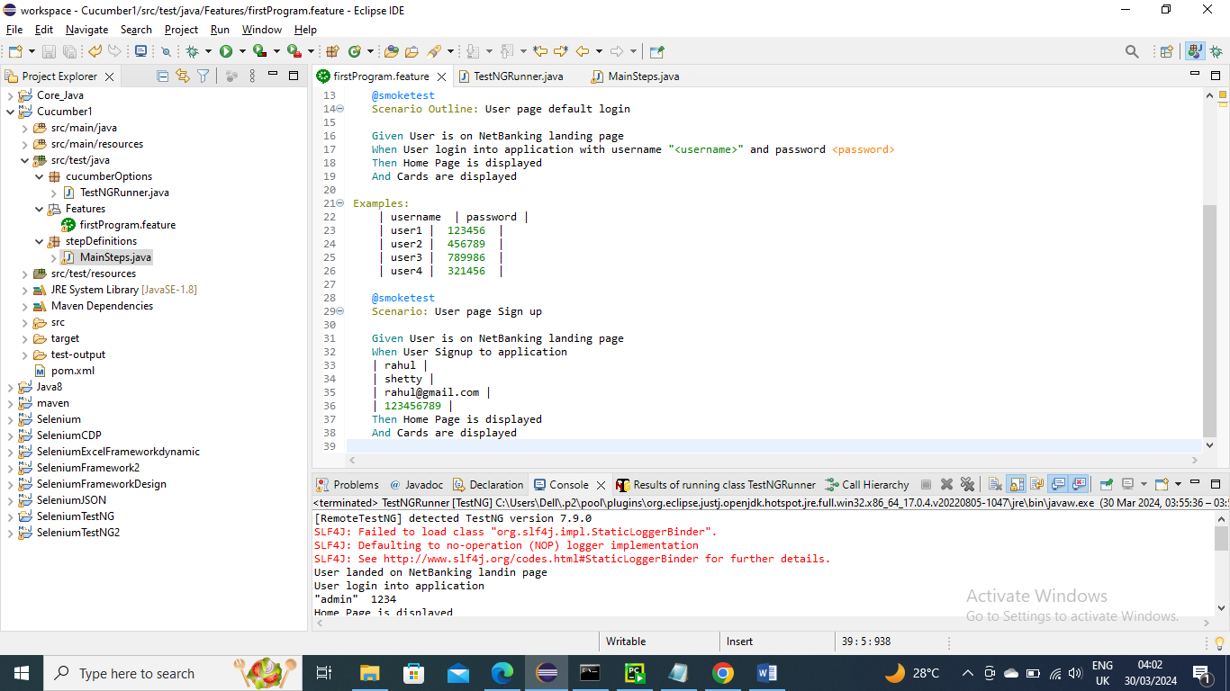

Below is stepDefinition code

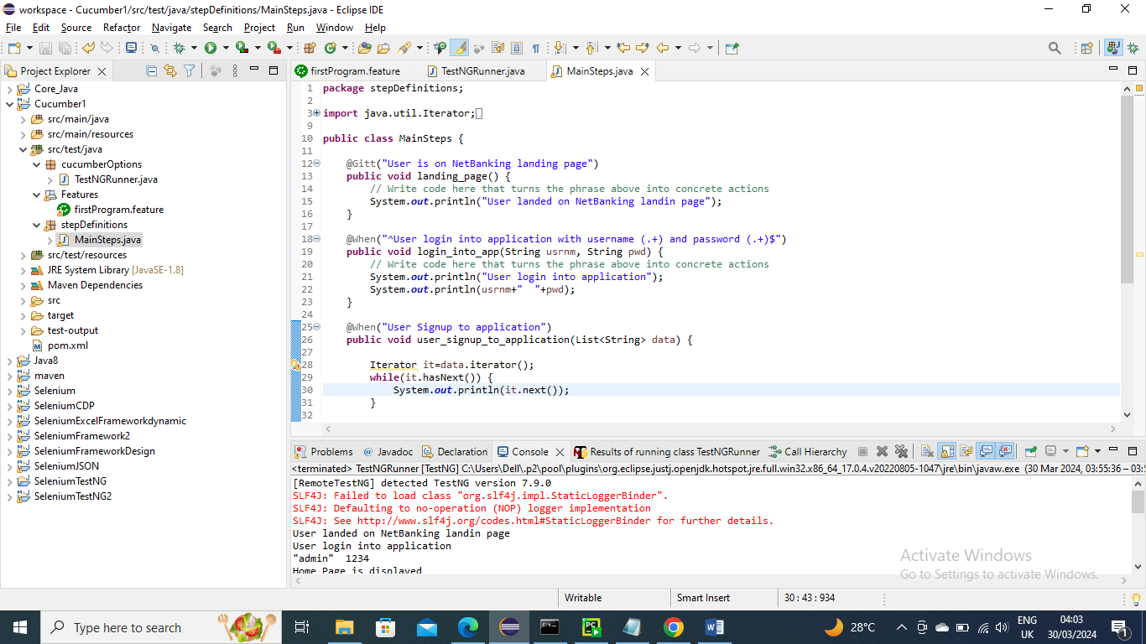

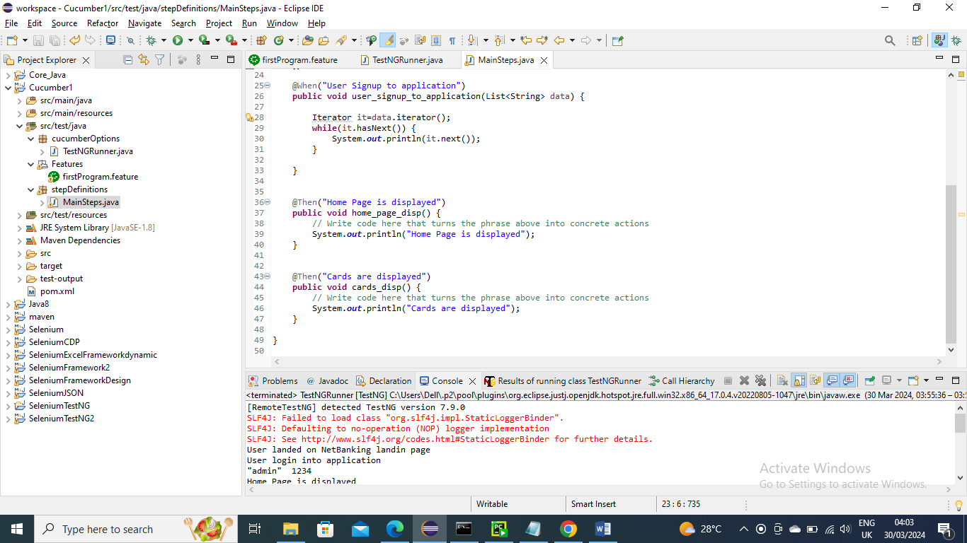

Below Main class change/add tag and give the name for which you want to run and run it



Below is the output……As expected only Admin page has run

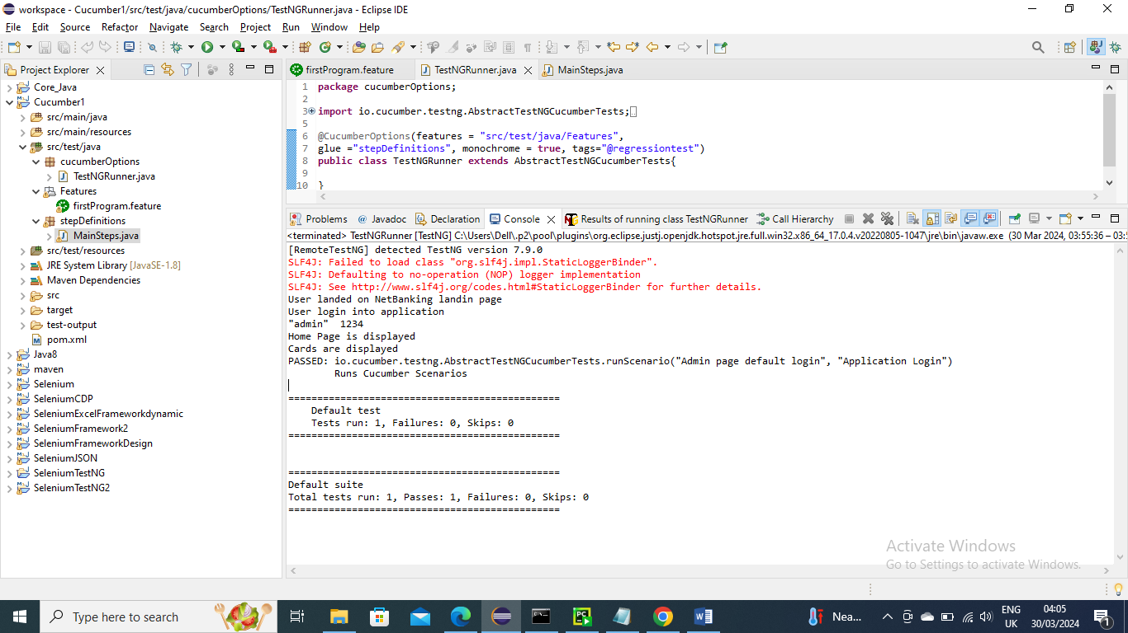

----------------------------

You can have multiple tags as well for same scenario as below

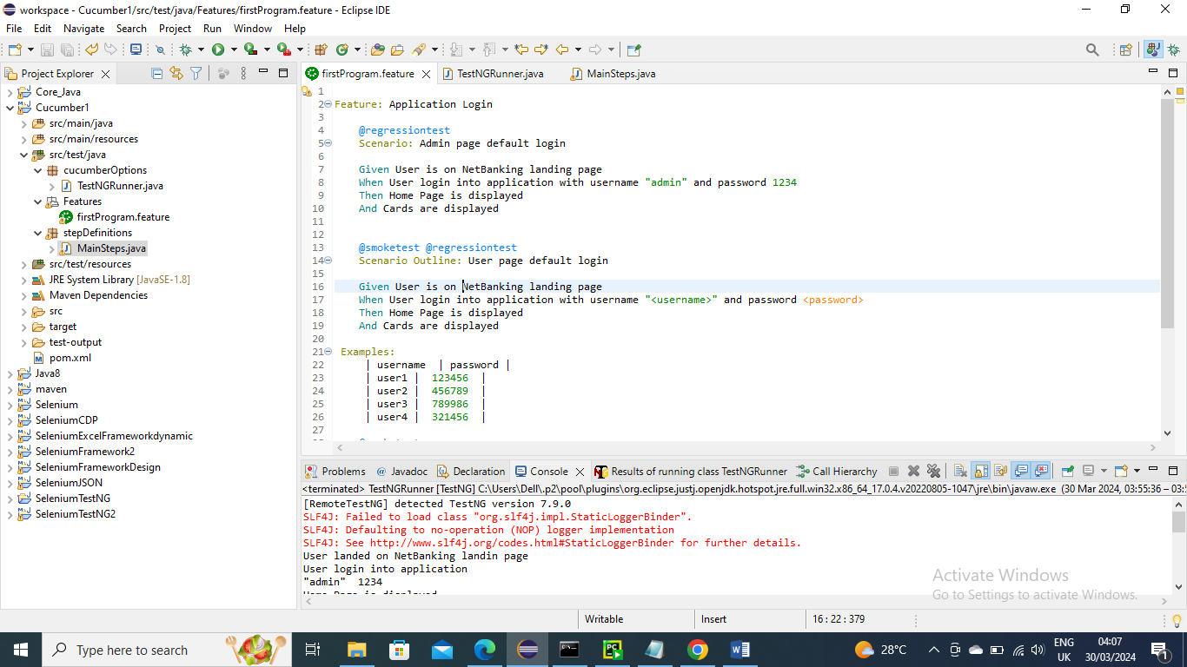

--------------------------

Let’s say you want to run if we tag is either smoketest or regression test you can make the it to or condition in Main class and run it

Below is the feature file

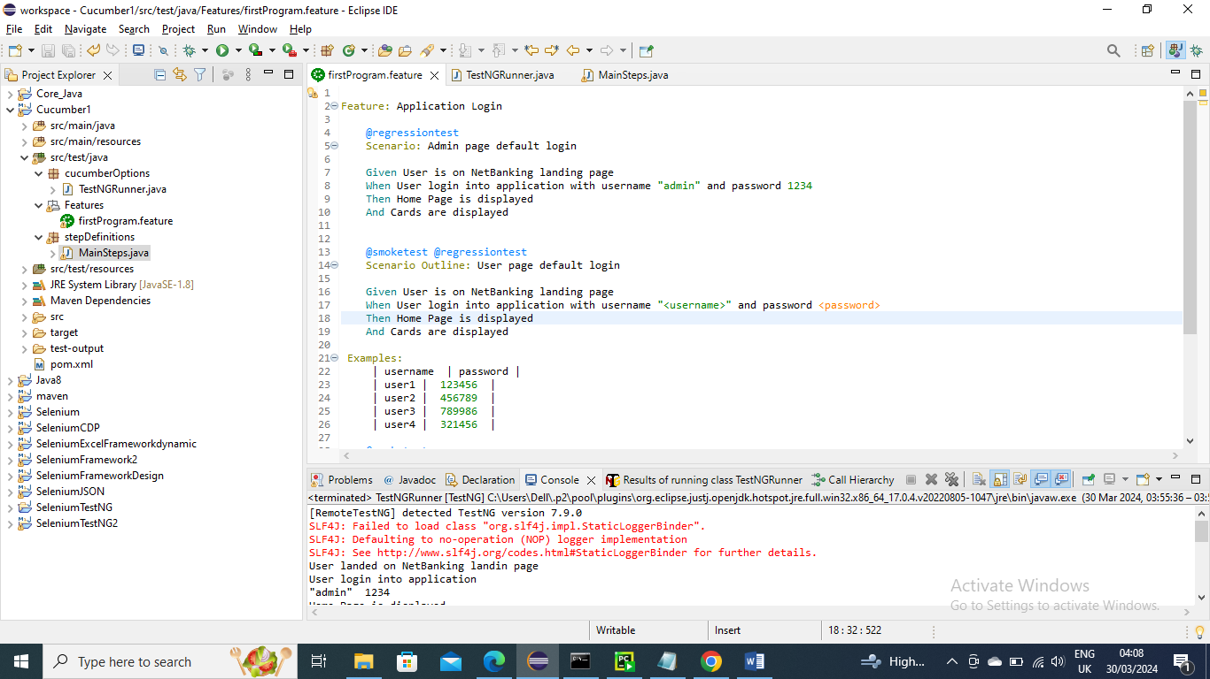

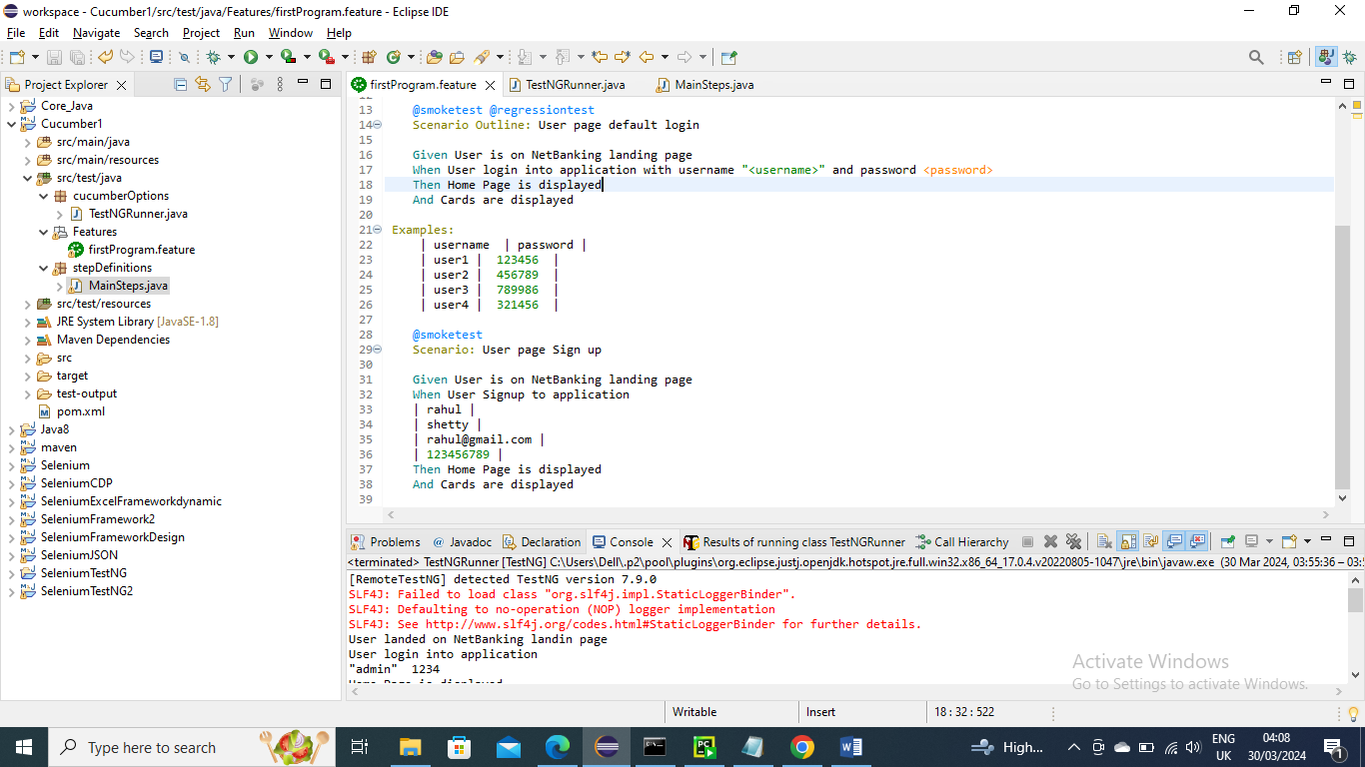

Below is stepDefinition file

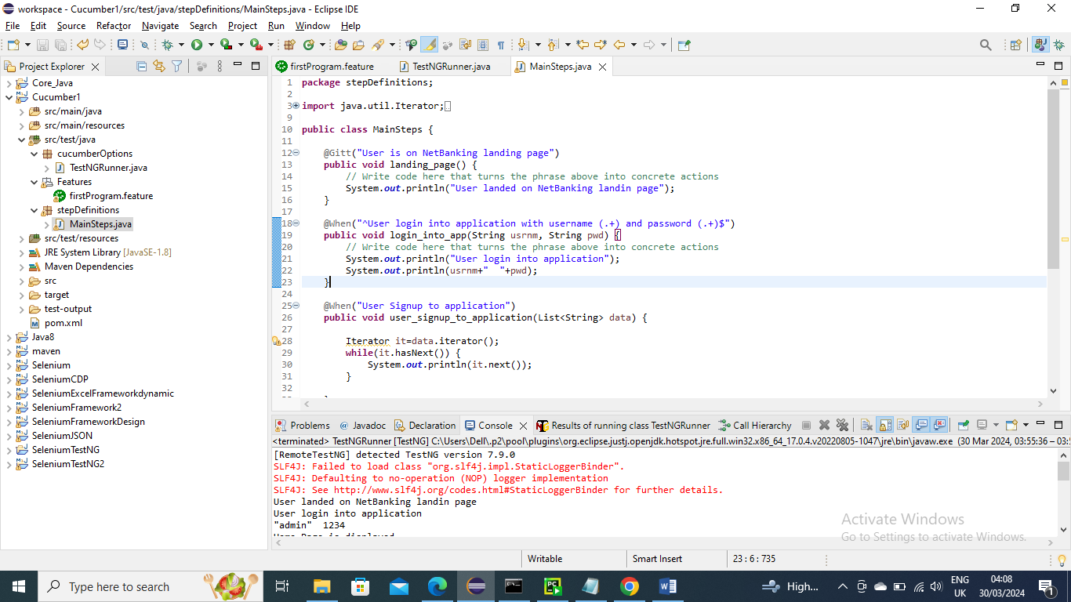

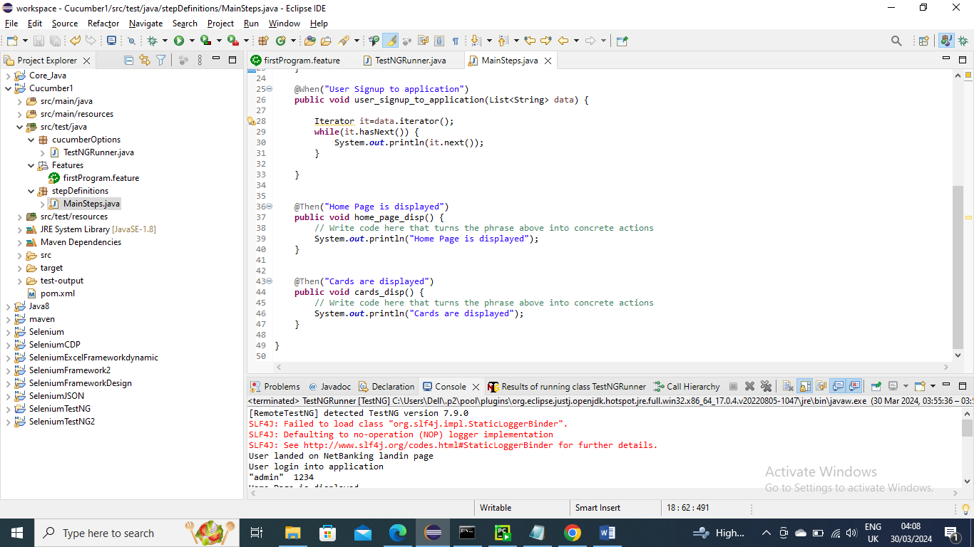

Below is Main class where we gave or condition for both tags and run it

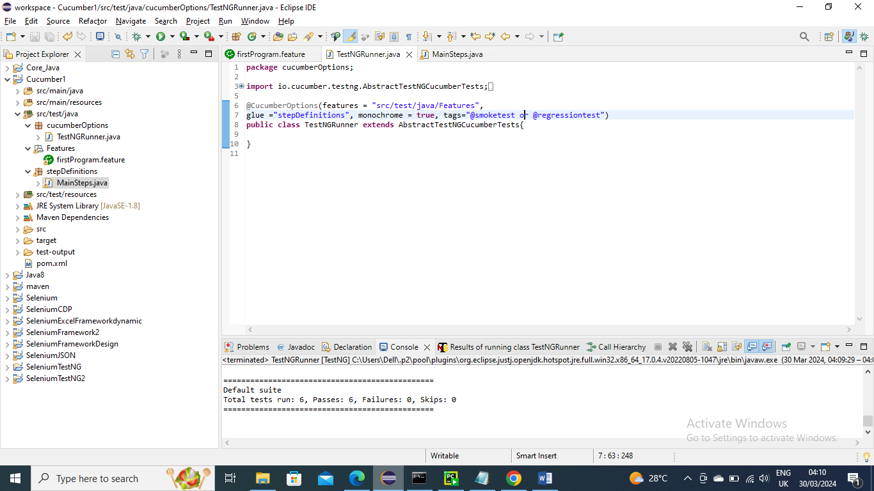

Below is output…….As expected since all are tagged with either Smoke or regression all scenarios are run

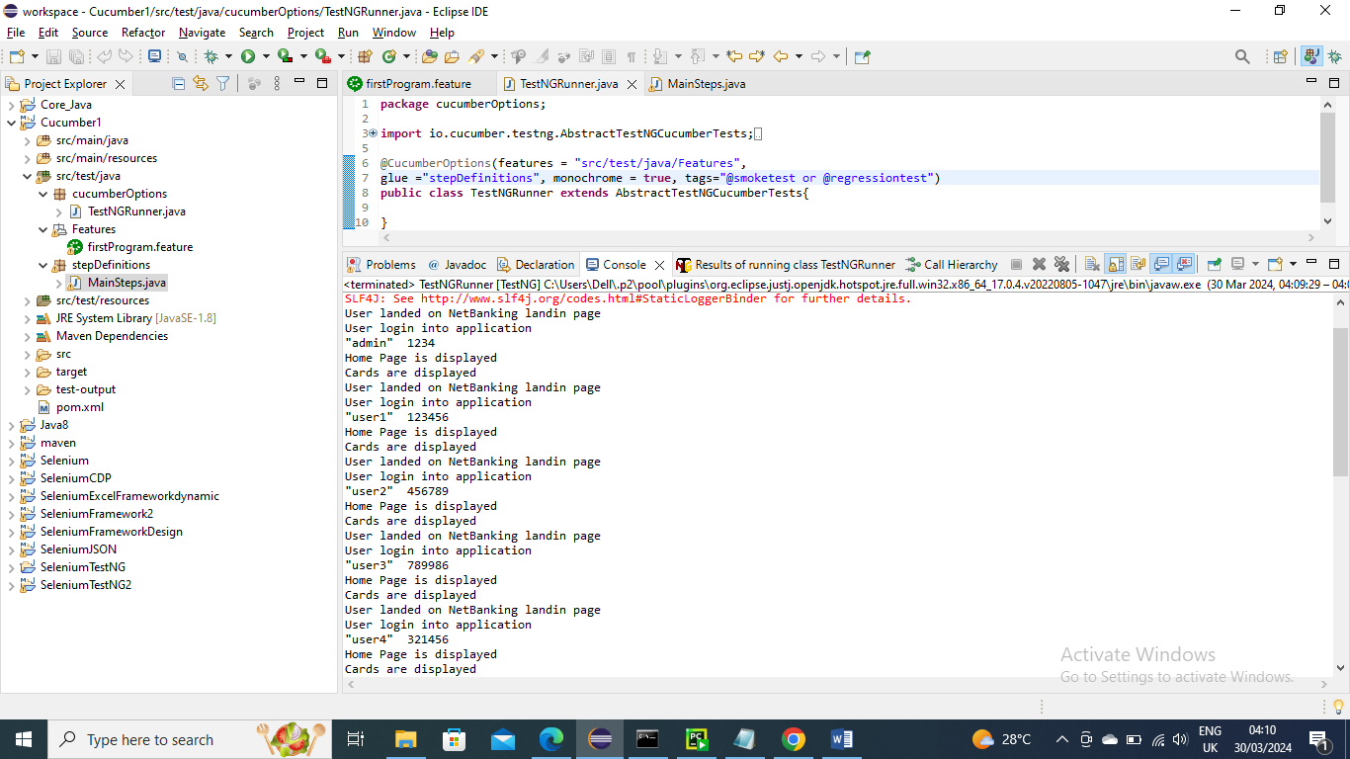

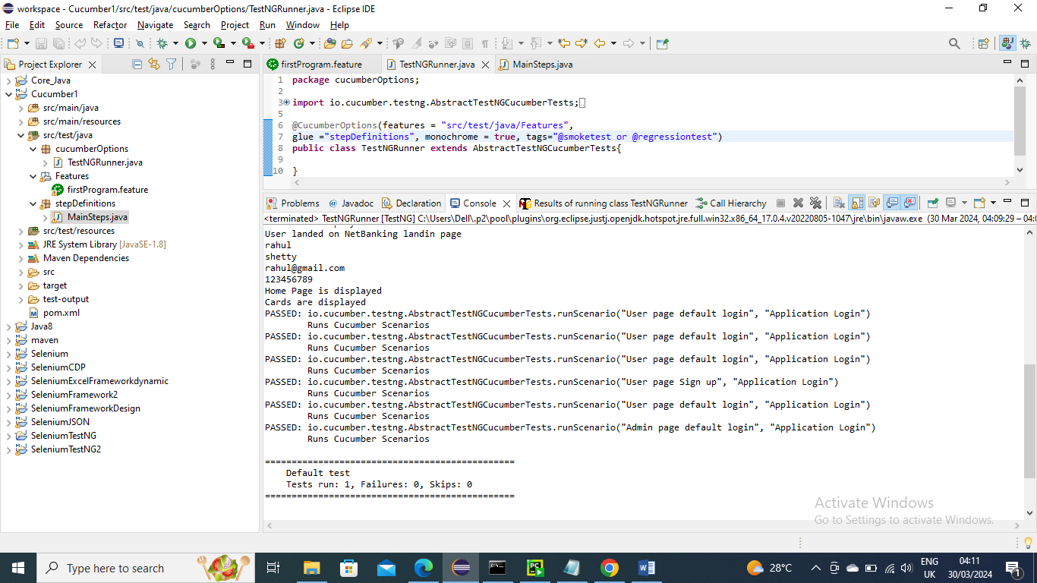

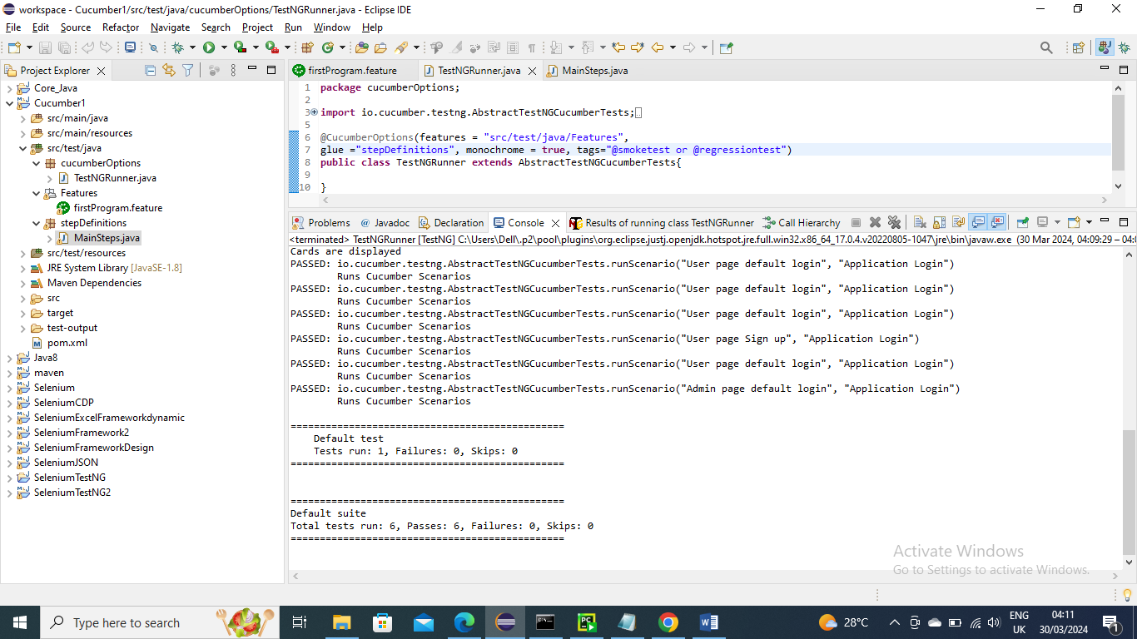

--------------------------------------

Now for example you want to run where it has both smoke and regression you can update main class with and condition and run it

Note – I did not upload pics for other classes since they are same as above

Below make condition as and ….and run it

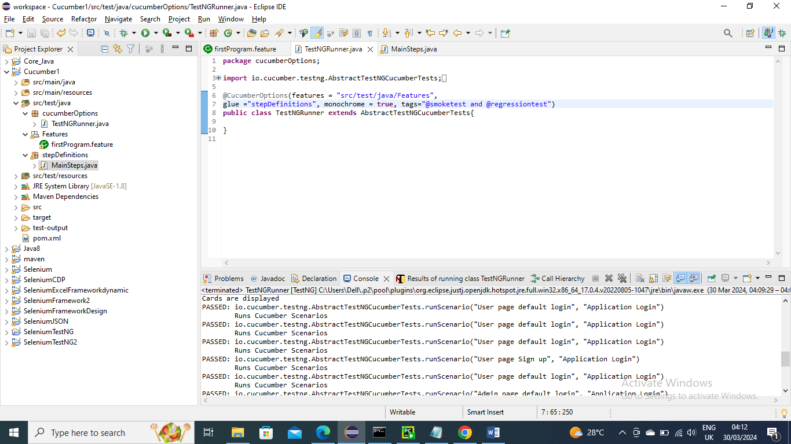

Below is the Output……………….. and as expected only User login has run since it has both smoke and regression test tag to it

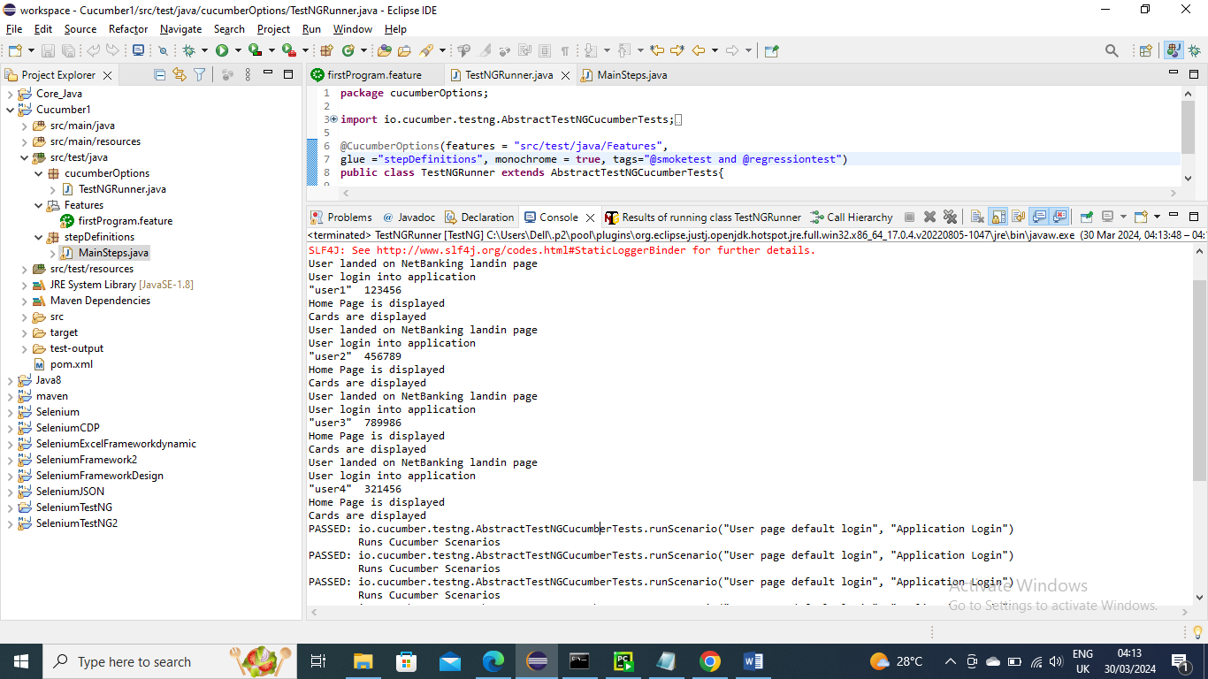

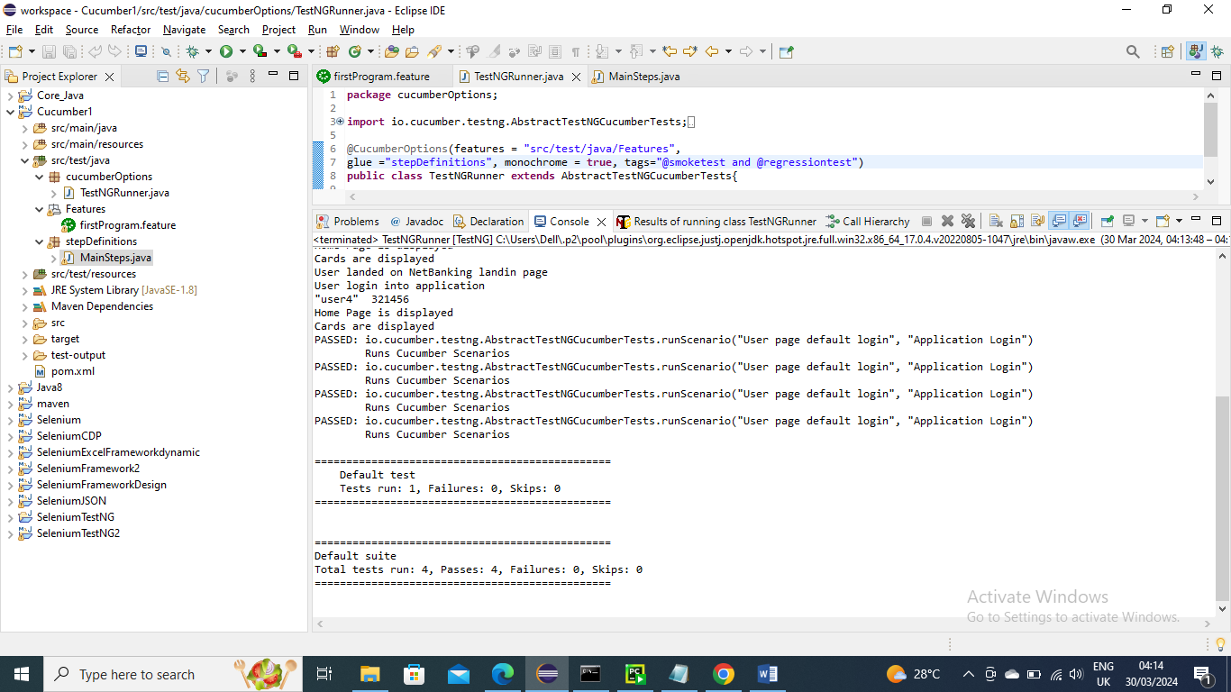

----------------------------------------

Now let’s say you want to run all the test cases except that are tagged with smoke you can give not condition in main class

Note – I did not upload pics for other classes since they are same as above

Below make condition as “not” ….and run it

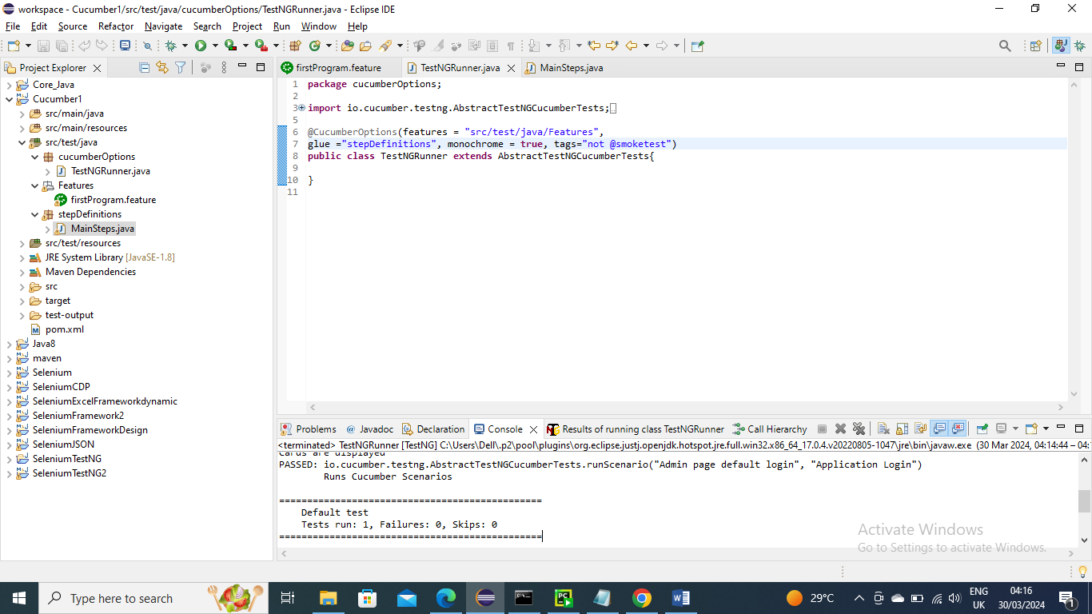

Below is the output……….as expected only admin page has run since it the only one that’s not tagged with smoketest

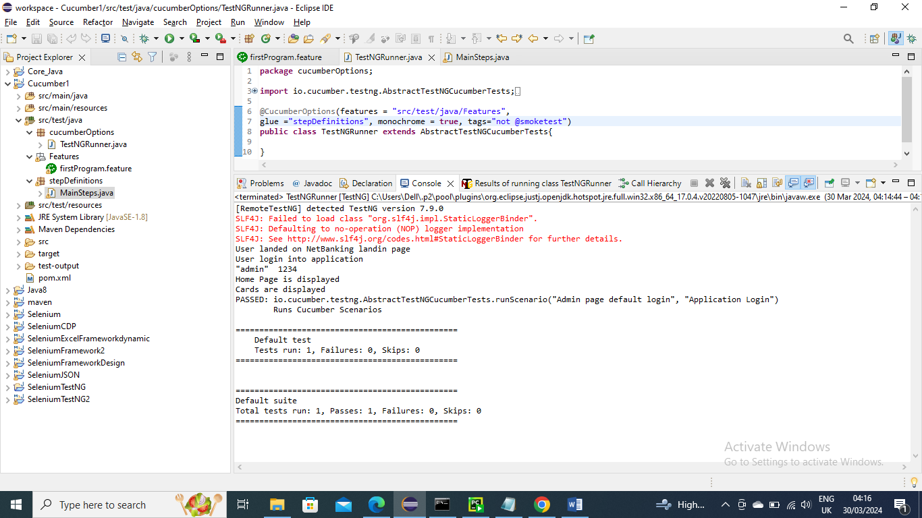

----------------------------------------

Let’ say a scenario where before you run every scenario there is pre-requisite for example before you run scenario you want to load the URL or something then in that case “Background” comes into picture provided the feature file all scenarios have that pre-requisite as common since that Background is applicable to all scenarios and it will run before all scenarios

In below before we ran Admin, user or sign up we need to execute the URL right and say that URL is common. In that case we can have Background for this feature file

Below in feature file we added Background and one condition to load URL

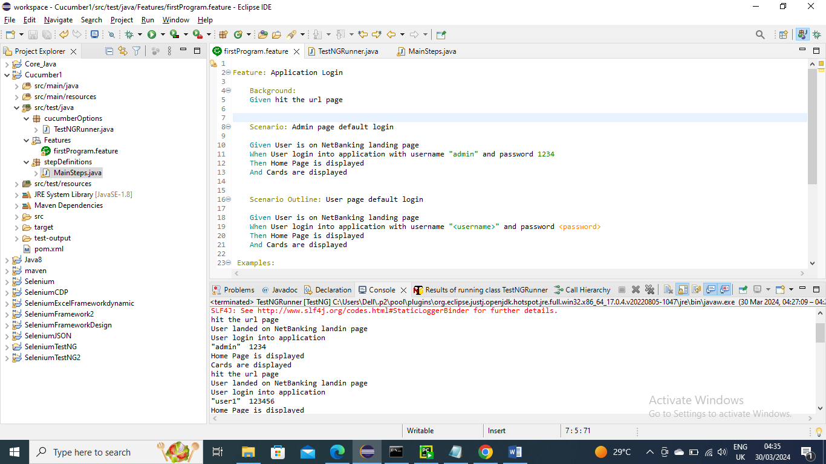

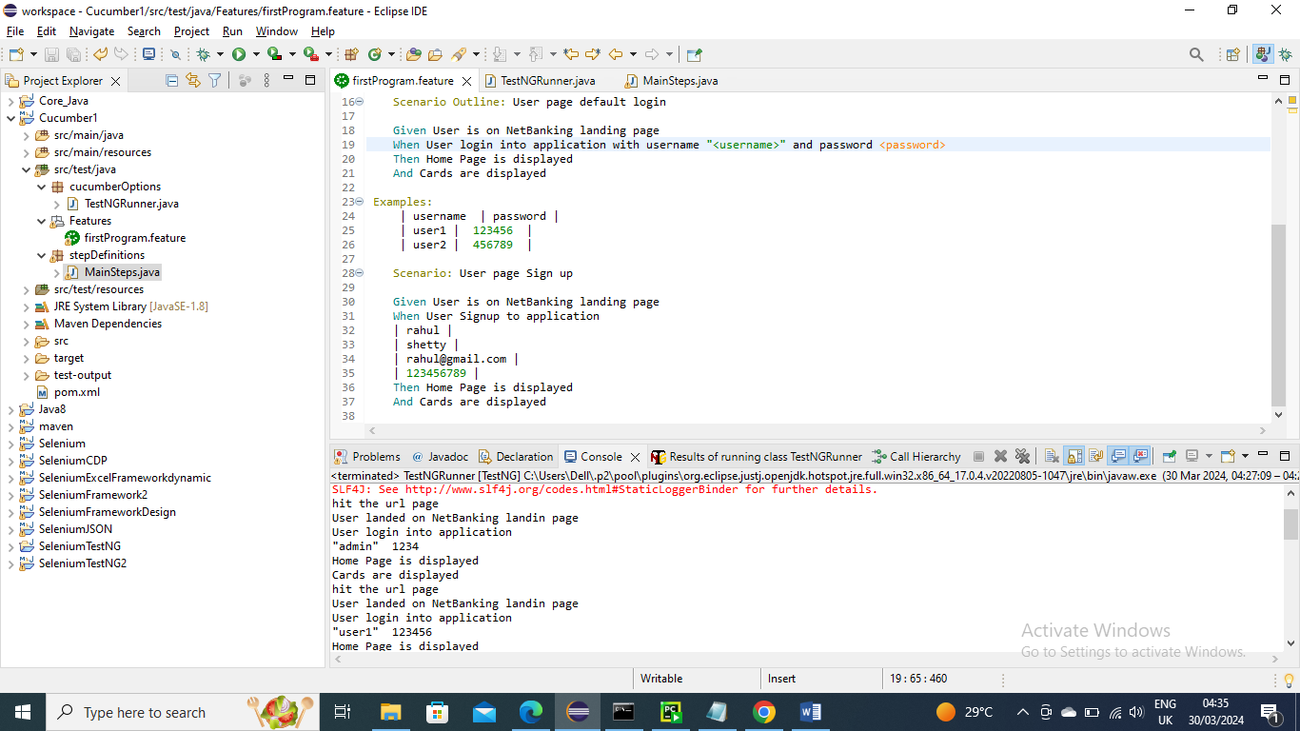

Below is stepDefinition file where I have handled that condition for Background to load the URL

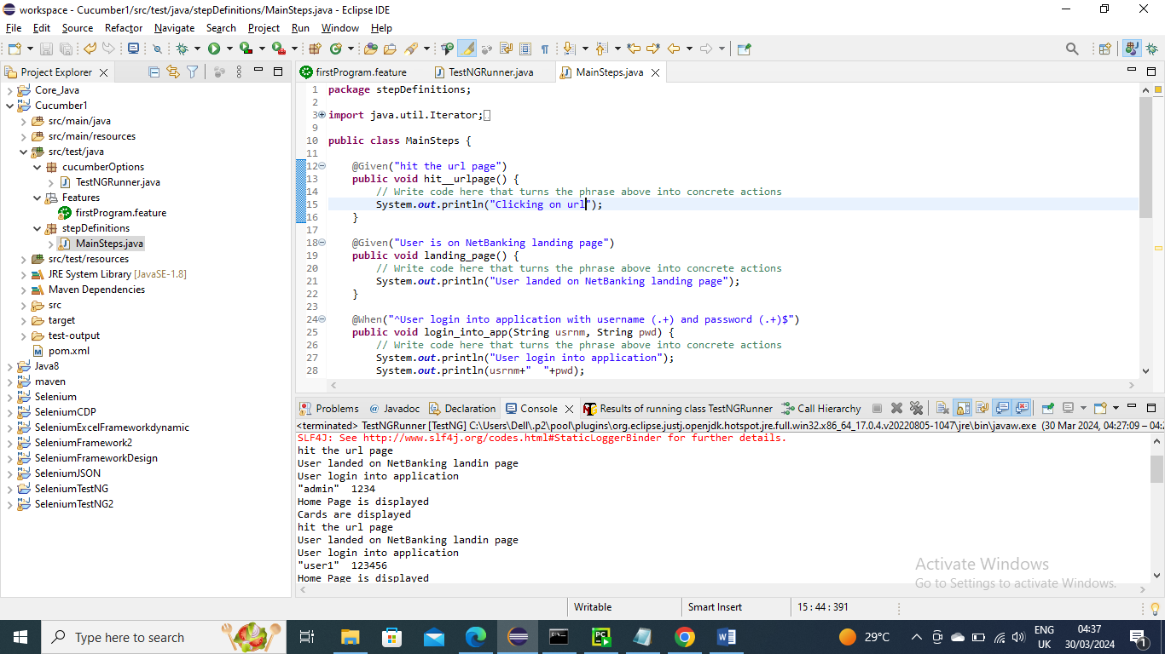

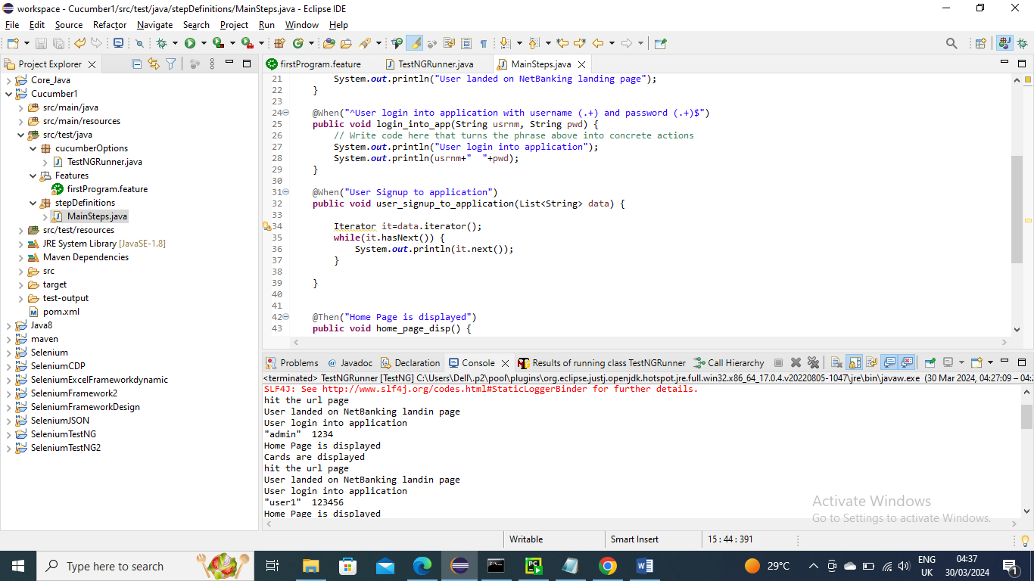

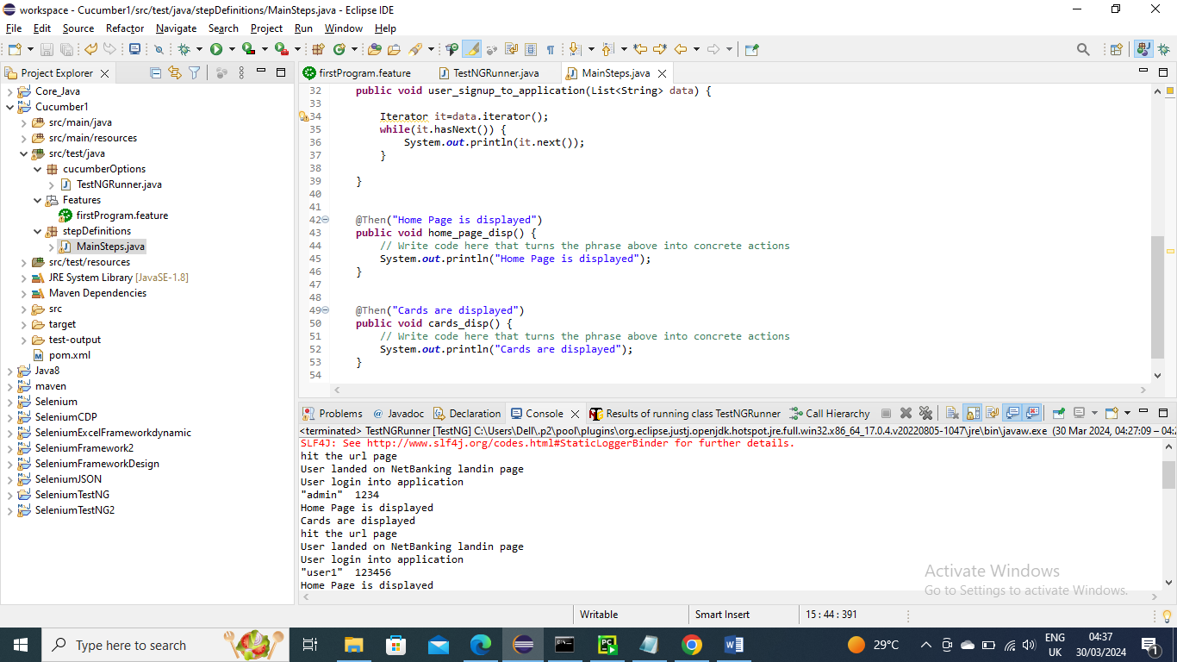

Run the main class

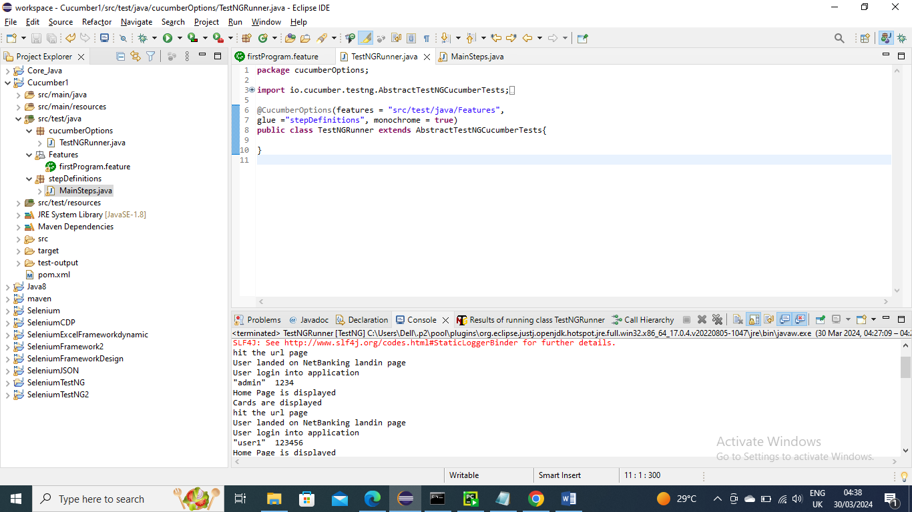

Below is the output…………And as you can see before executing all three scenarios it executed the background and we can see ”clicking on url” has been ran before the scenarios

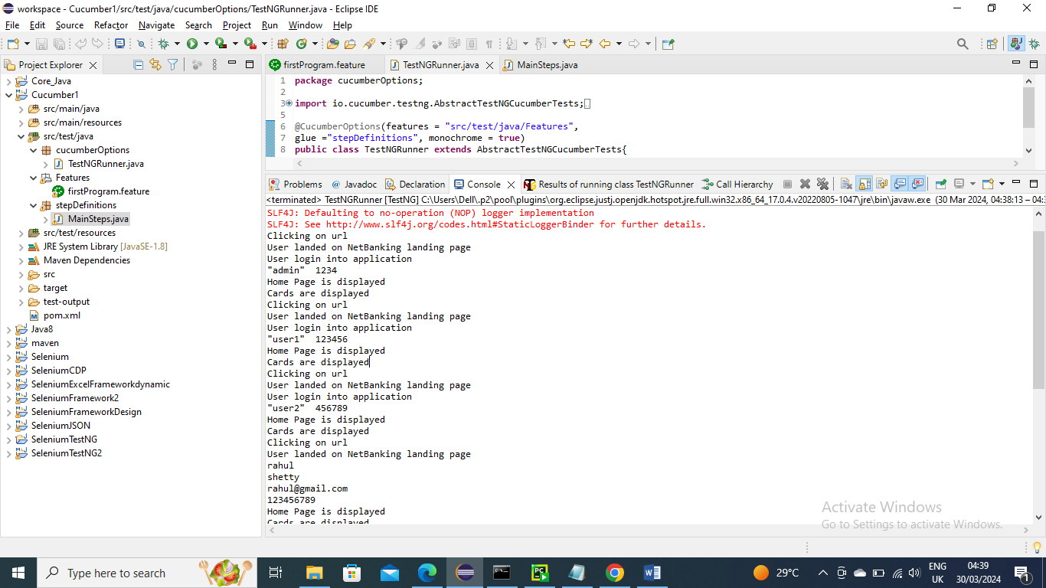

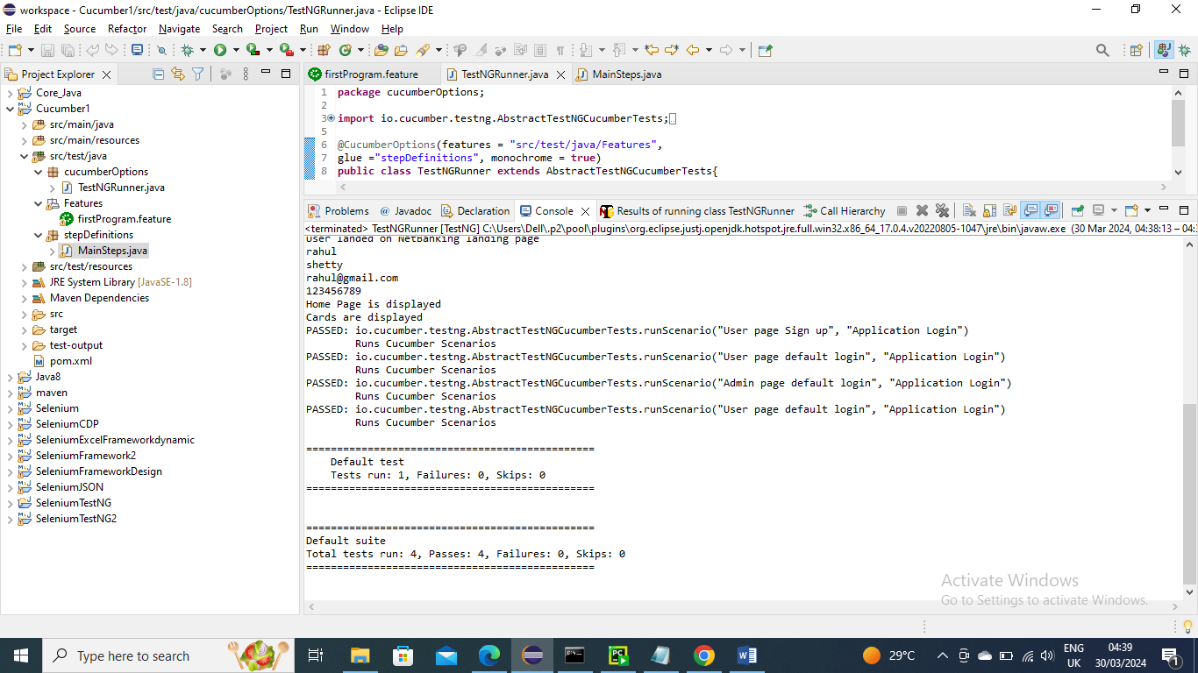

------------------------------------

But in above the drawback is the Background will run for every scenario….But what if the Scenarios pre-requisite is different. For example Admin, User and Sign up has different URL’s

To handle this we have concept of hooks…..That is we can run certain method before that scenario by having tag for that scenario and create a method and have annotation @Before and give the tag name

Below is the feature file with different tags for scenarios

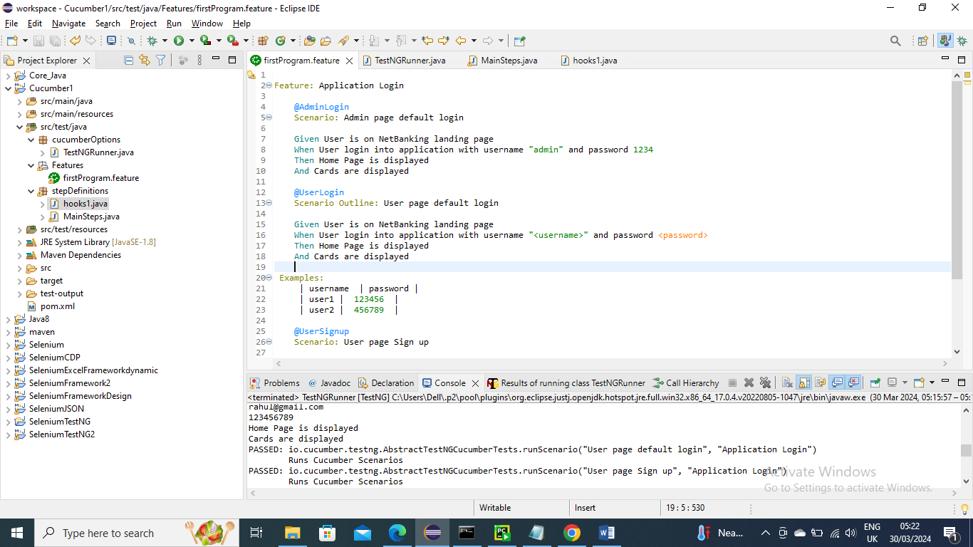

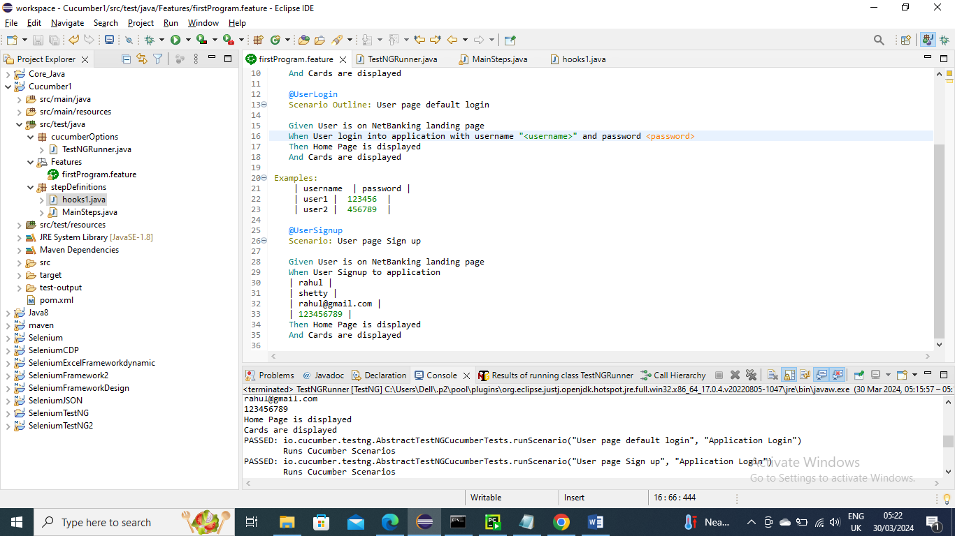

Below is stepDefinition/Mainsteps code where the scenario conditions are handled

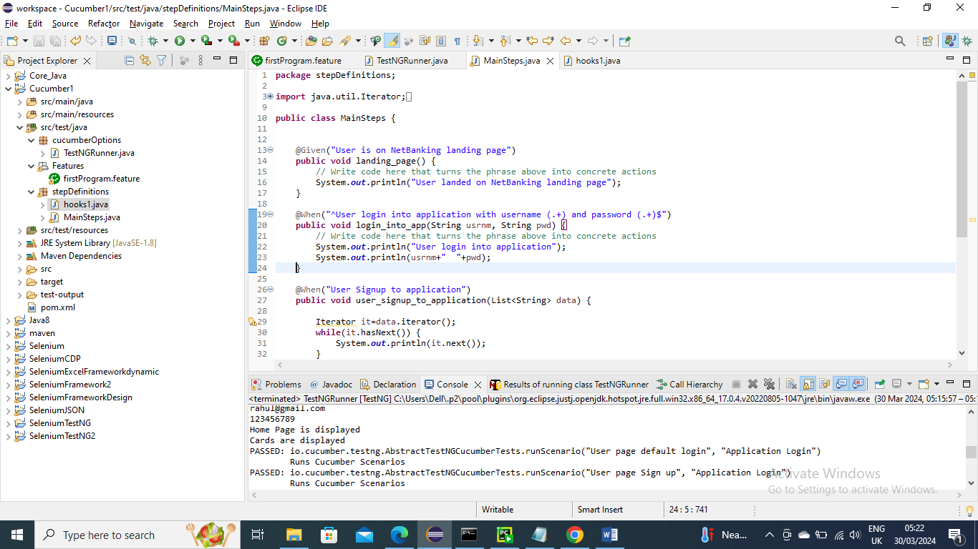

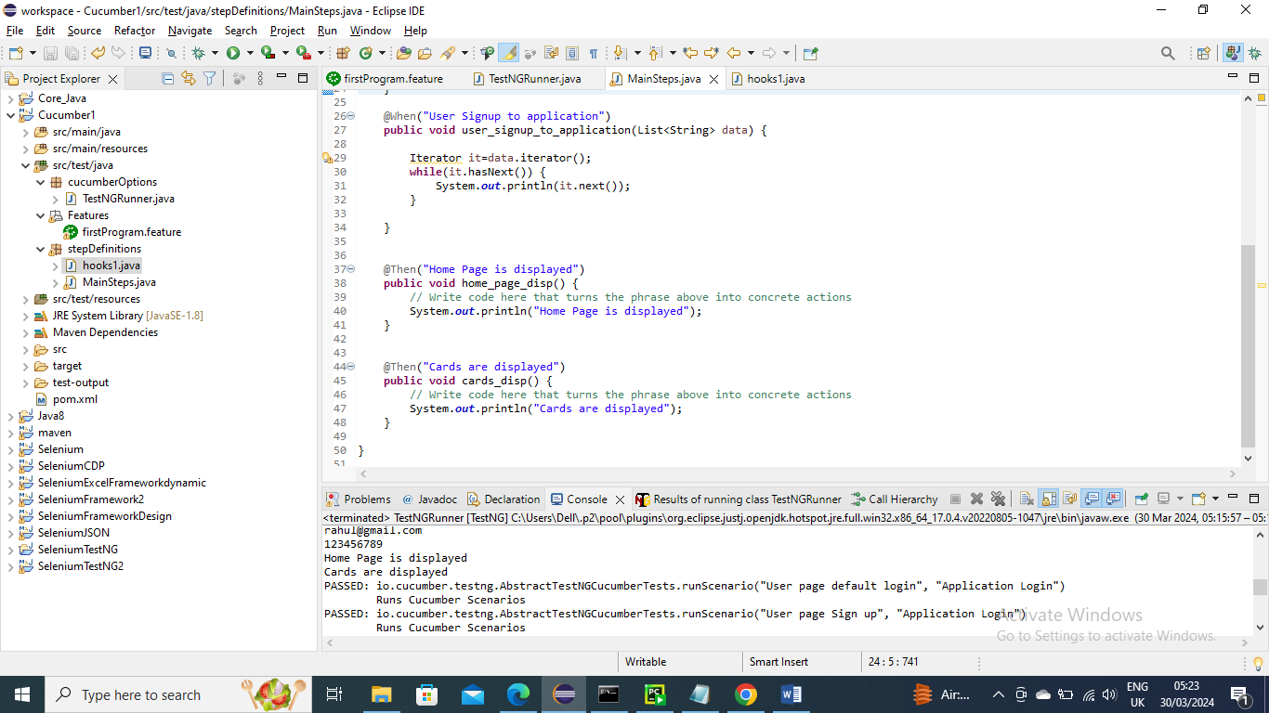

Below is the stepDefinitions/hooks1 file where pre-requiste for each scenario is handled. As you can see for each tag scenario there is different URL to hit

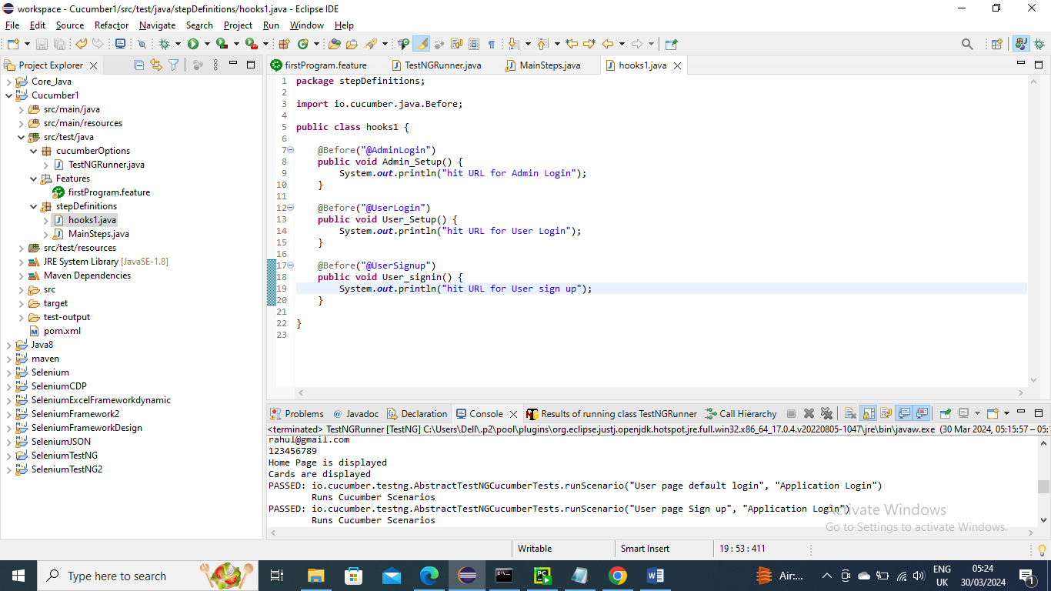

Below is Main class and run it

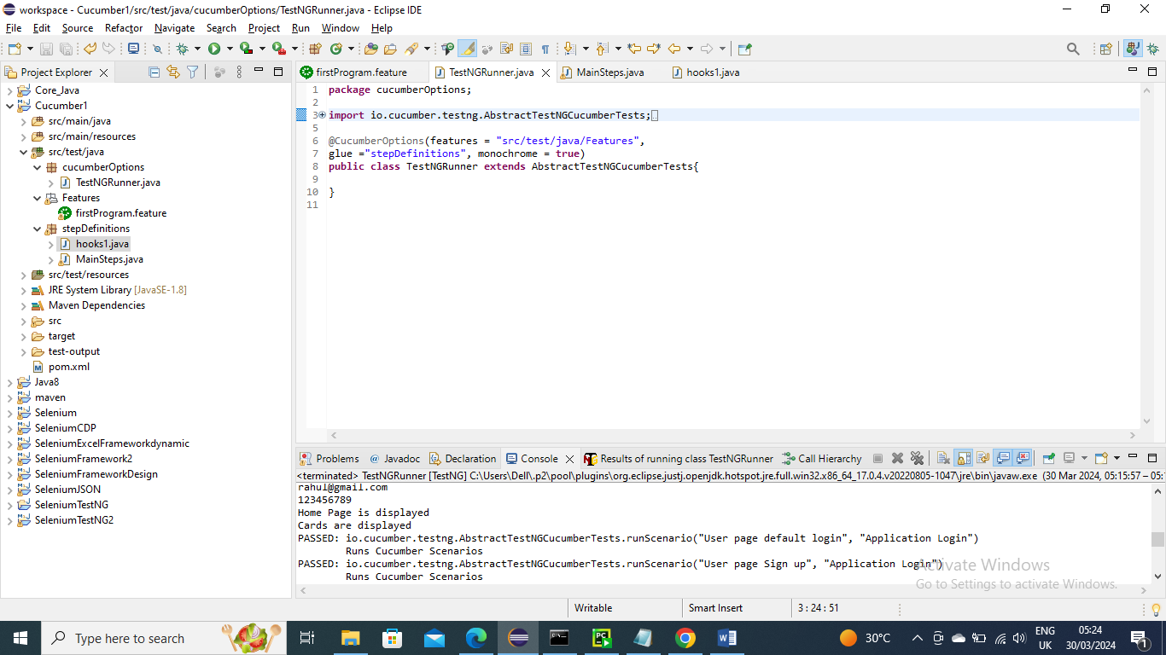

Below is the output……As expected the different URL’s has been run for each scenario

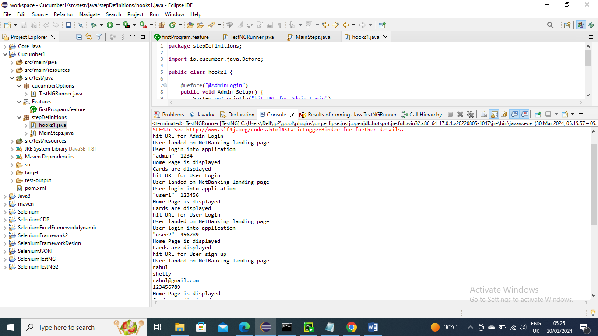

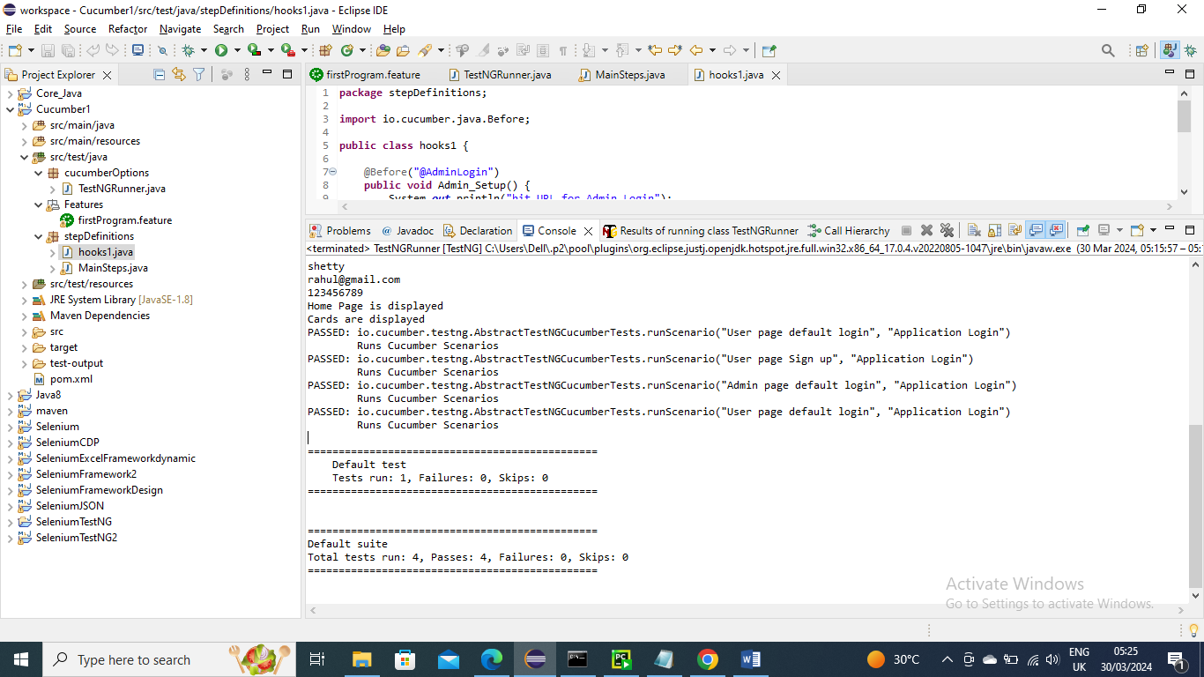

--------------------------------------------------

Below is an example where you want to close browser or page after every scenario run. You can use have annotation @Before and give the tag name of that scenario

Note – same for above feature no programs changed except below program where I created methods for @After (“@tagname”)

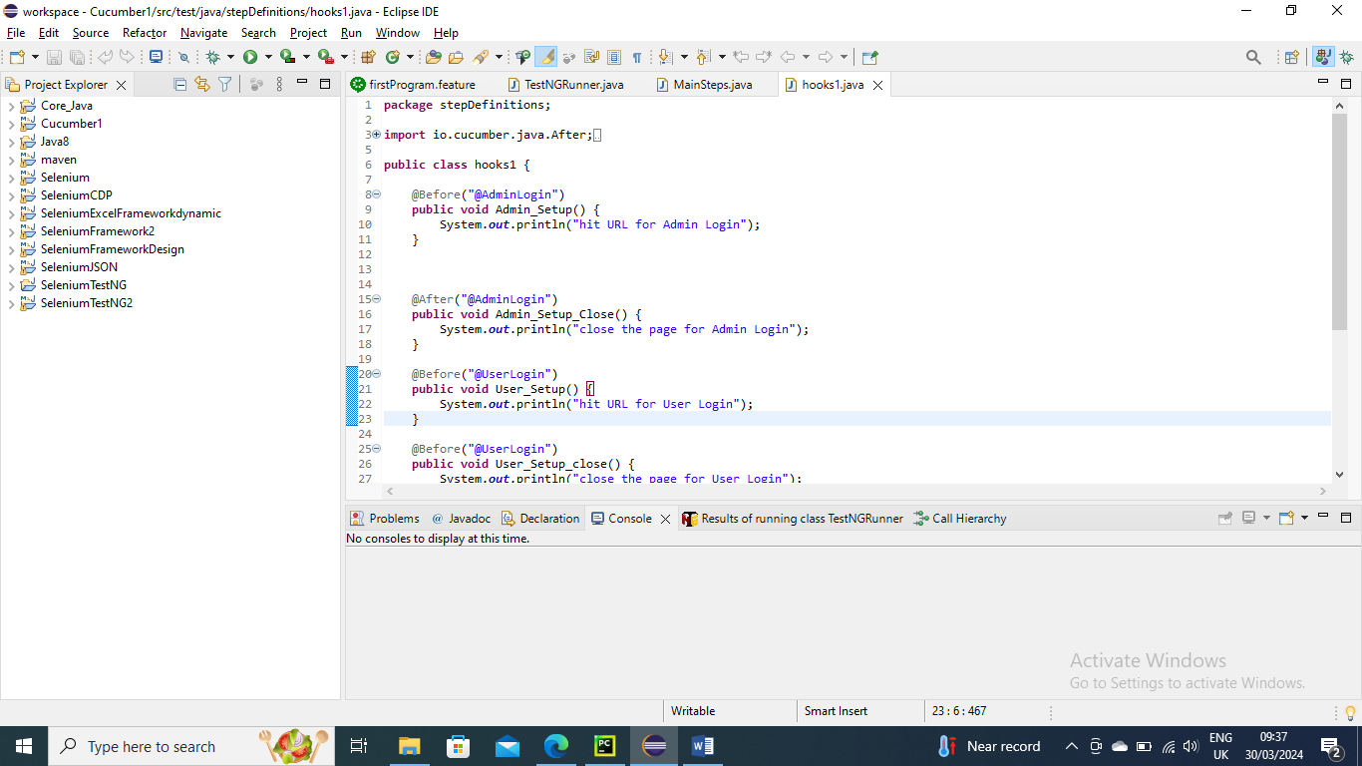

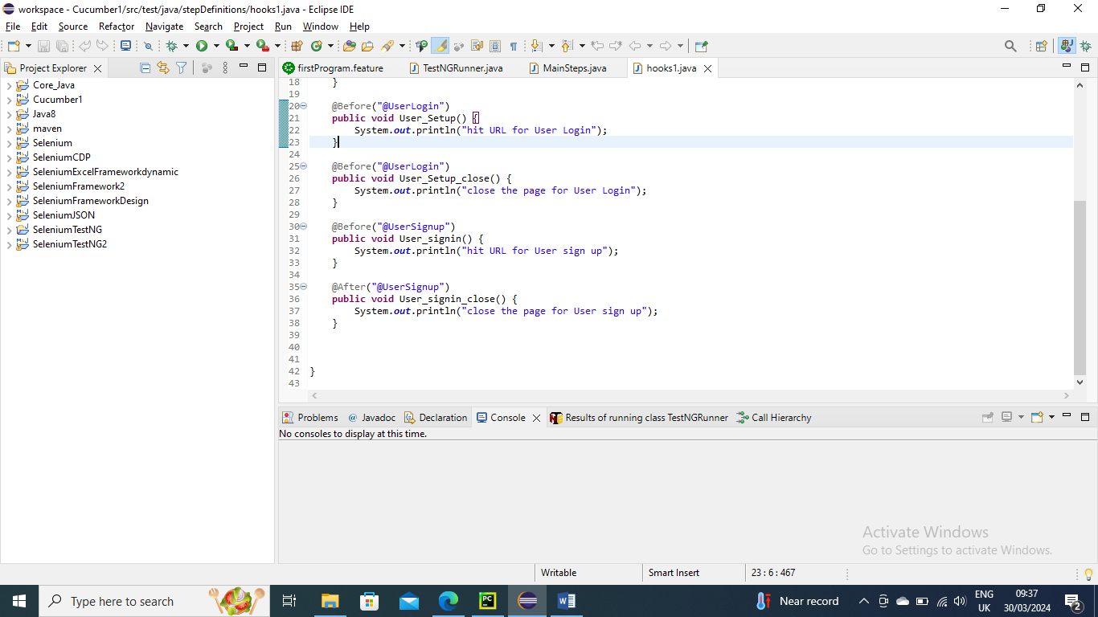

Now run the Main class as usual

Below is the output……As you can see all the three After methods have run after each scenario methods have ran

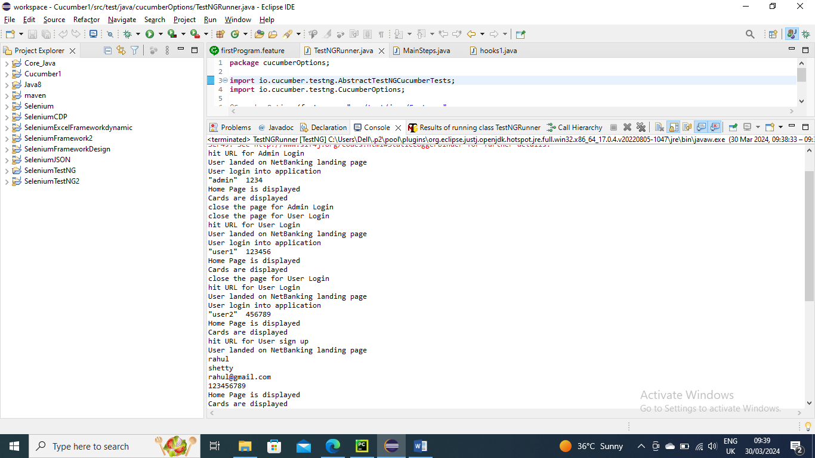

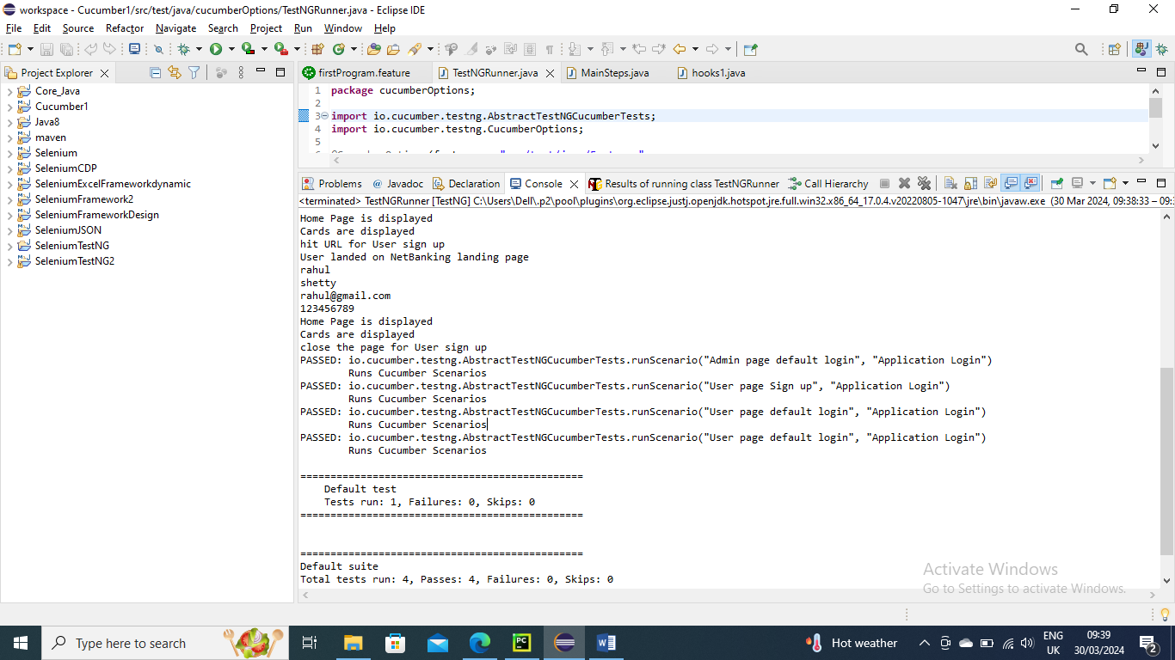

------------------------------------------------

Now say you don’t want to use each after method for each scenario and you want to close all files at once using single method. You can do my just giving @after method without any tag name

Or even after using @after with tagname you want to user just @after without tag so that you want close some miscellaneous browsers you can do that as well

Note – all other programs are same expect below

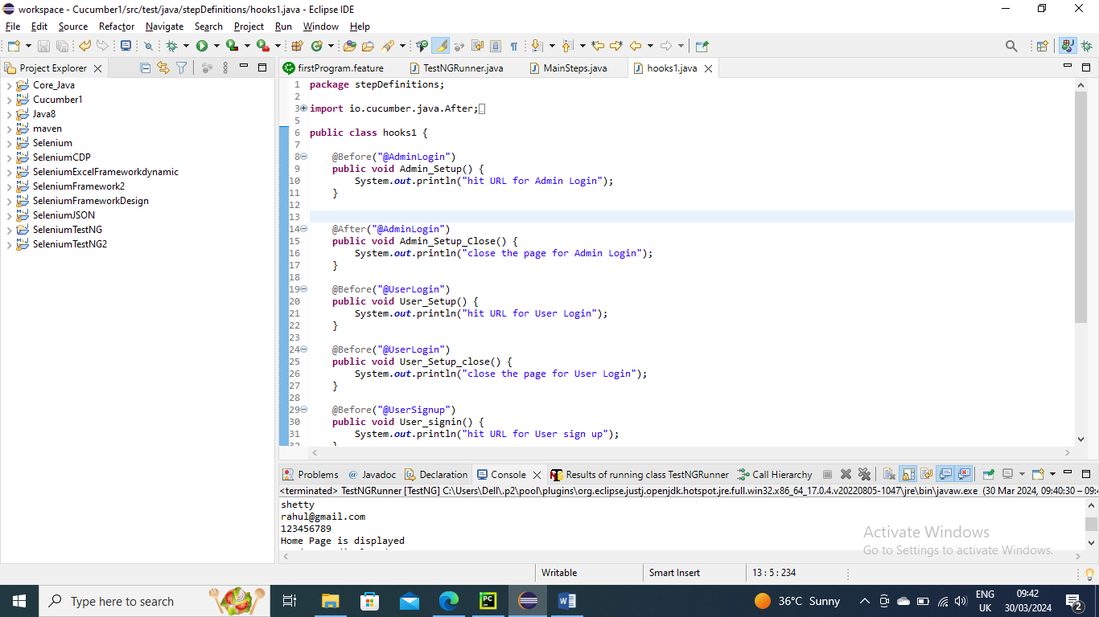

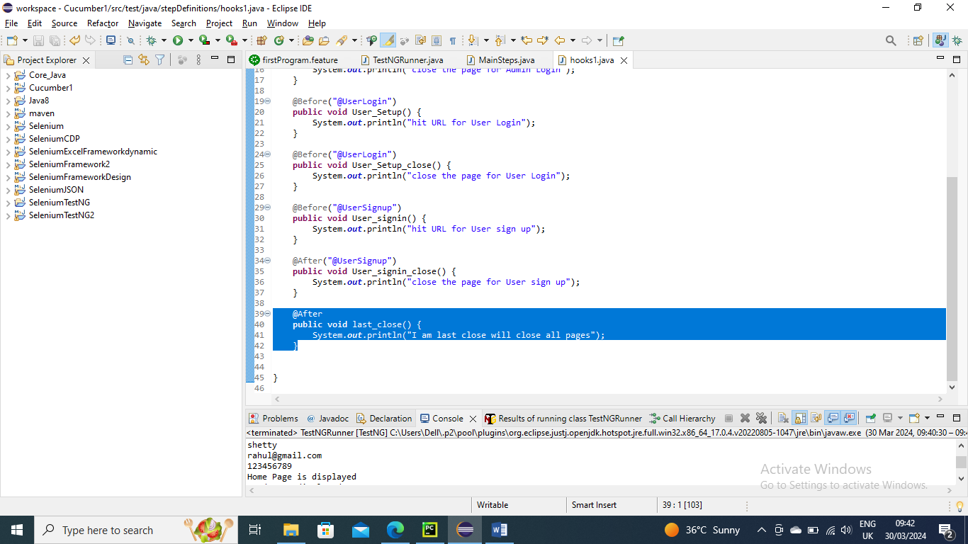

Run the main class as usual

Below is the output…….You can see just @after method without tag has run at last

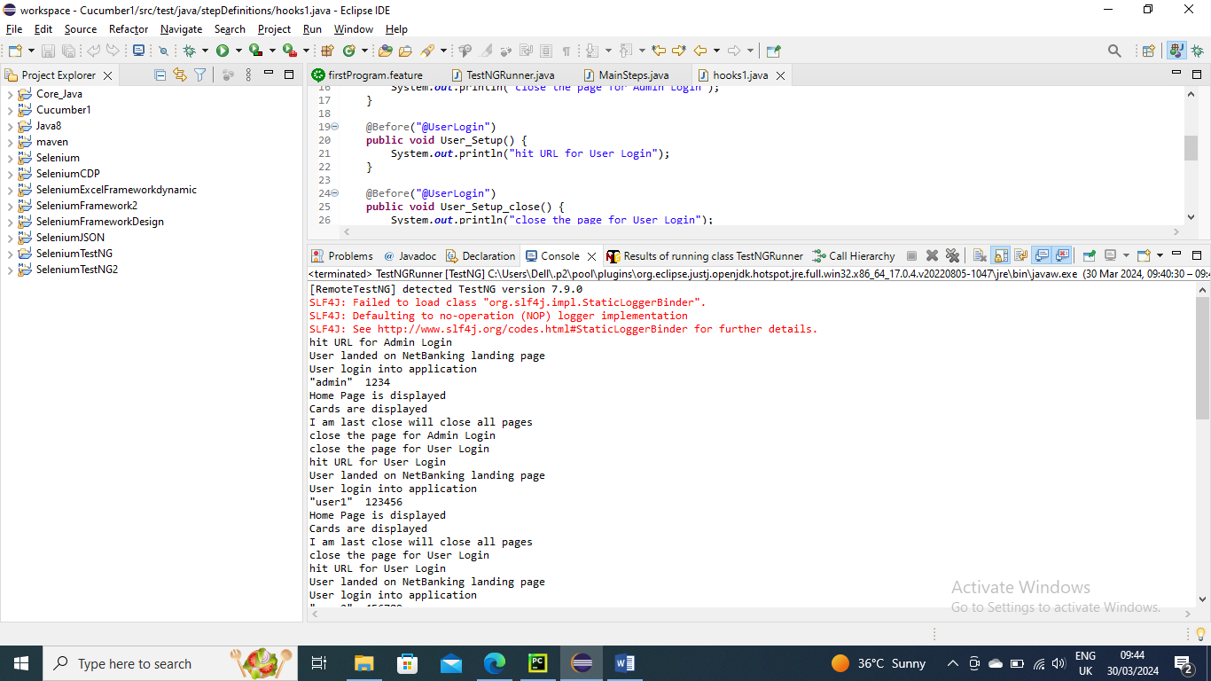

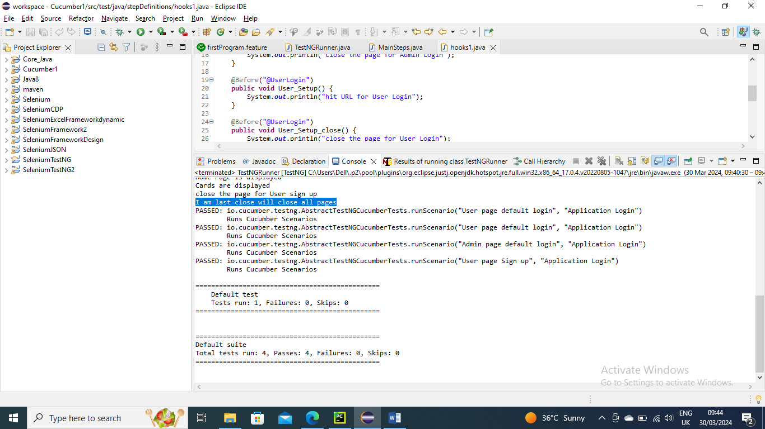

----------------------------------------

Reporting in Cucumber

Below is basic feature file

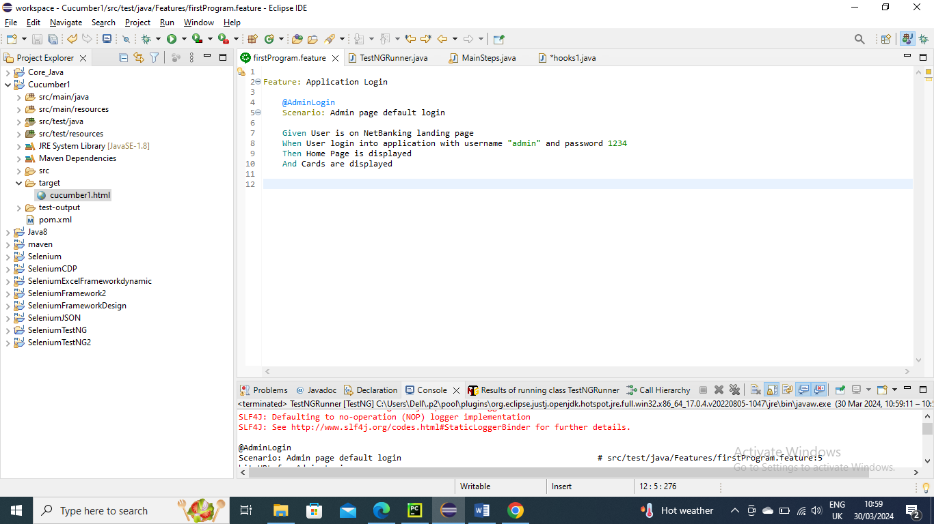

Below is the stepDefinitions/Mainsteps program where the conditions are created for handling

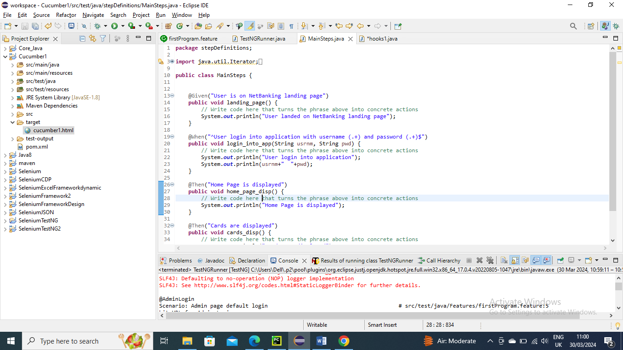

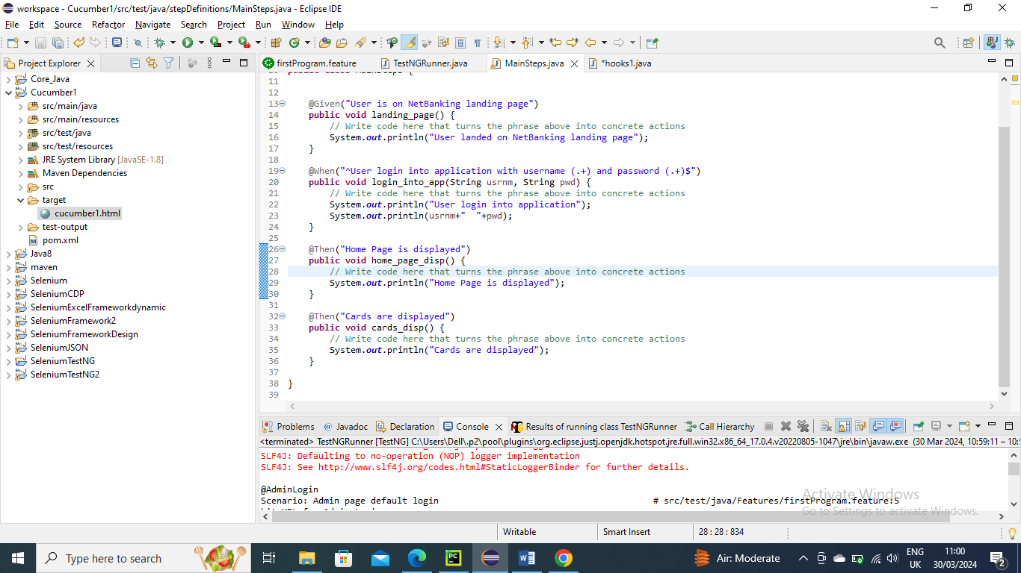

Below is the stepDefinitions/hooks1 for handing before and after running scenario

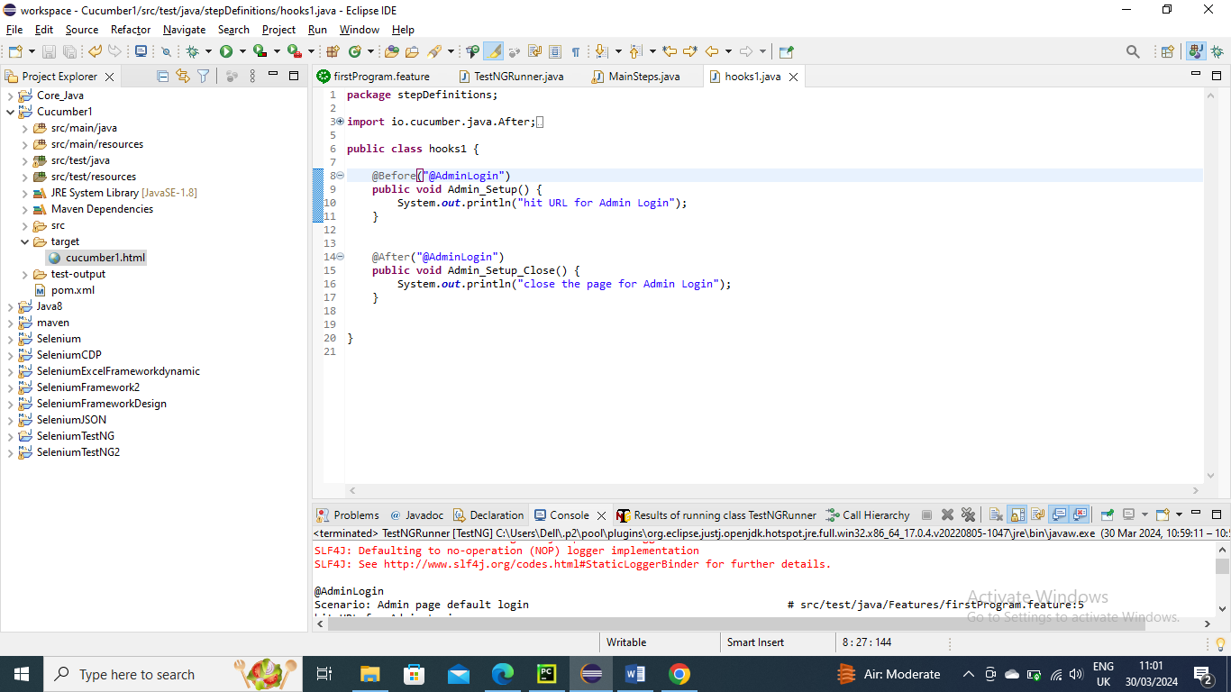

Now in the Main program give plugins as plugin ={"pretty","html:target/cucumber1.html"}

Here “pretty” means it will give green colour if passed and red colour if failed and second argument will be folder/html name.html

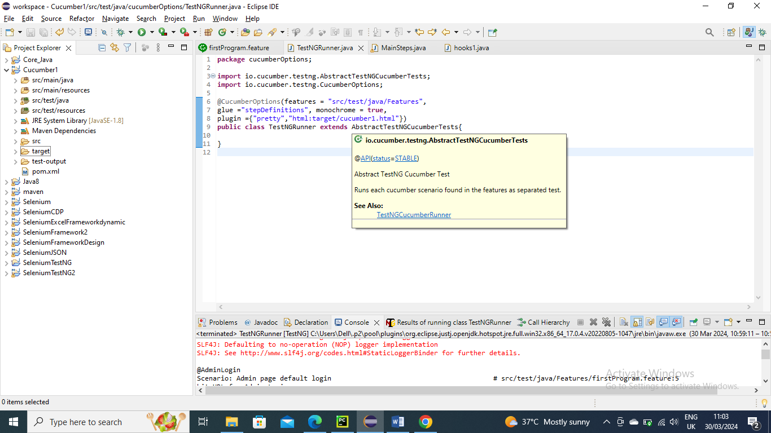

Now run the above class

Below is output……It is created in target folder as we mentioned In the program and with the name we mentioned



Now open the html…….as you can see it is passed

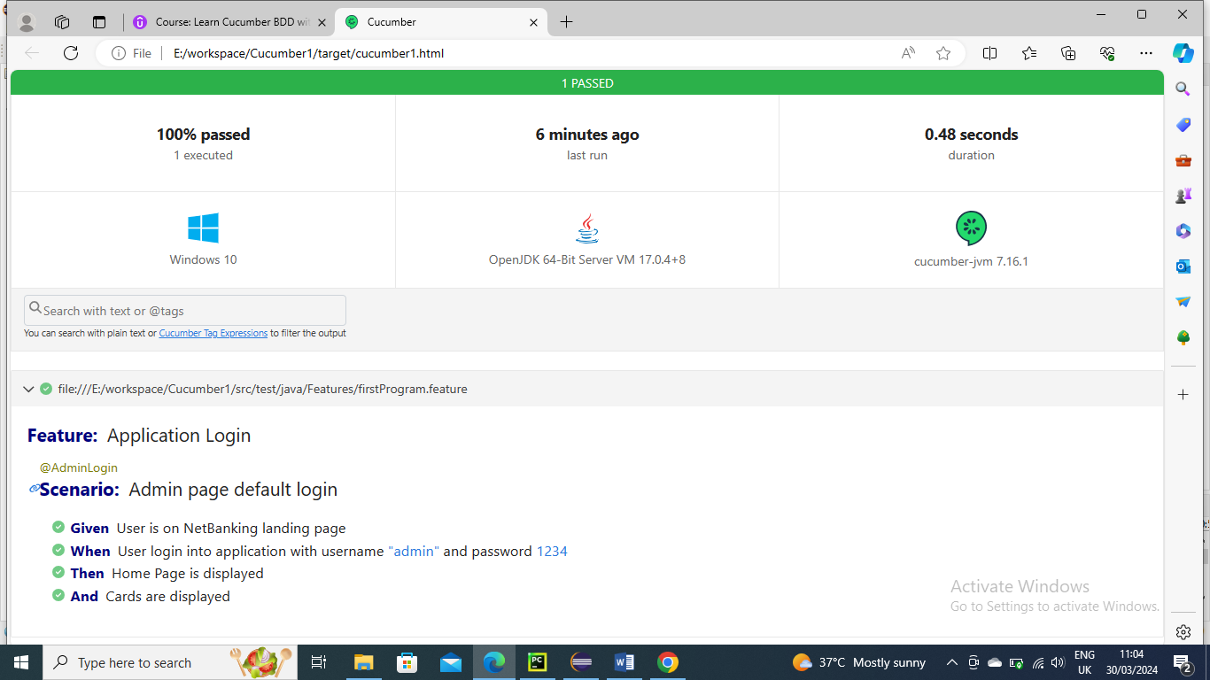

-------------------------------------------------

Now just to fail we will make to fail bone method condition created in stepDefinition program by asserttrue which is expecting true statement to false so that it fails

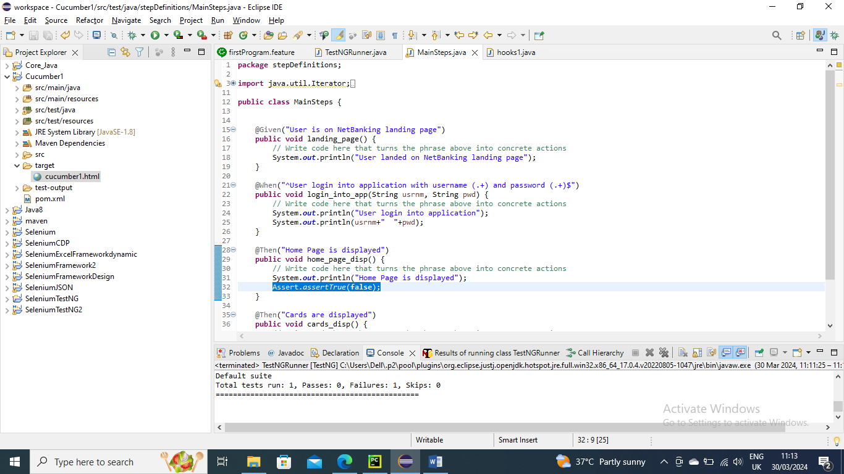

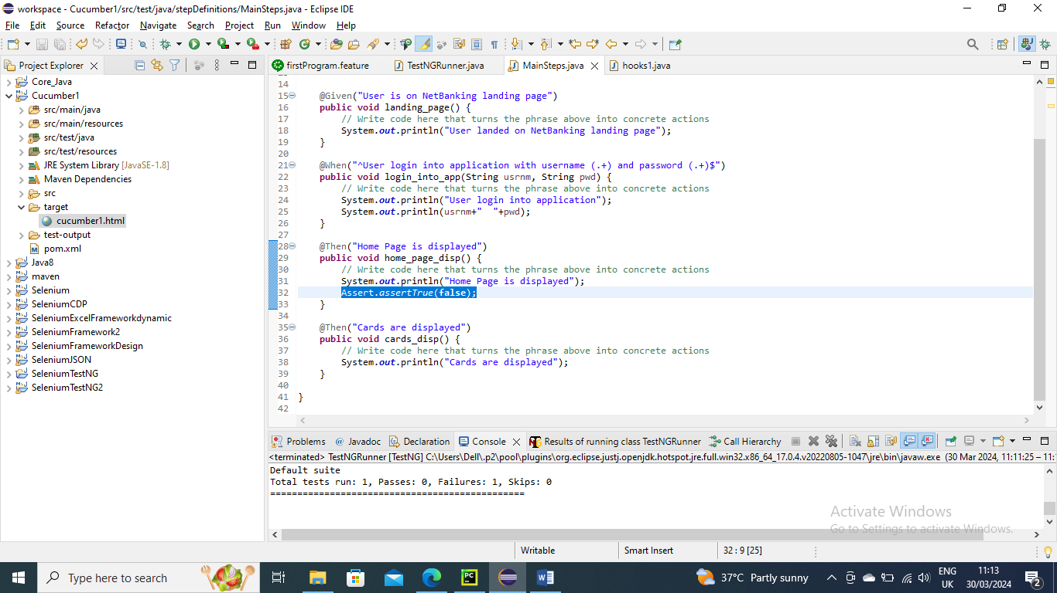

Now run the main class

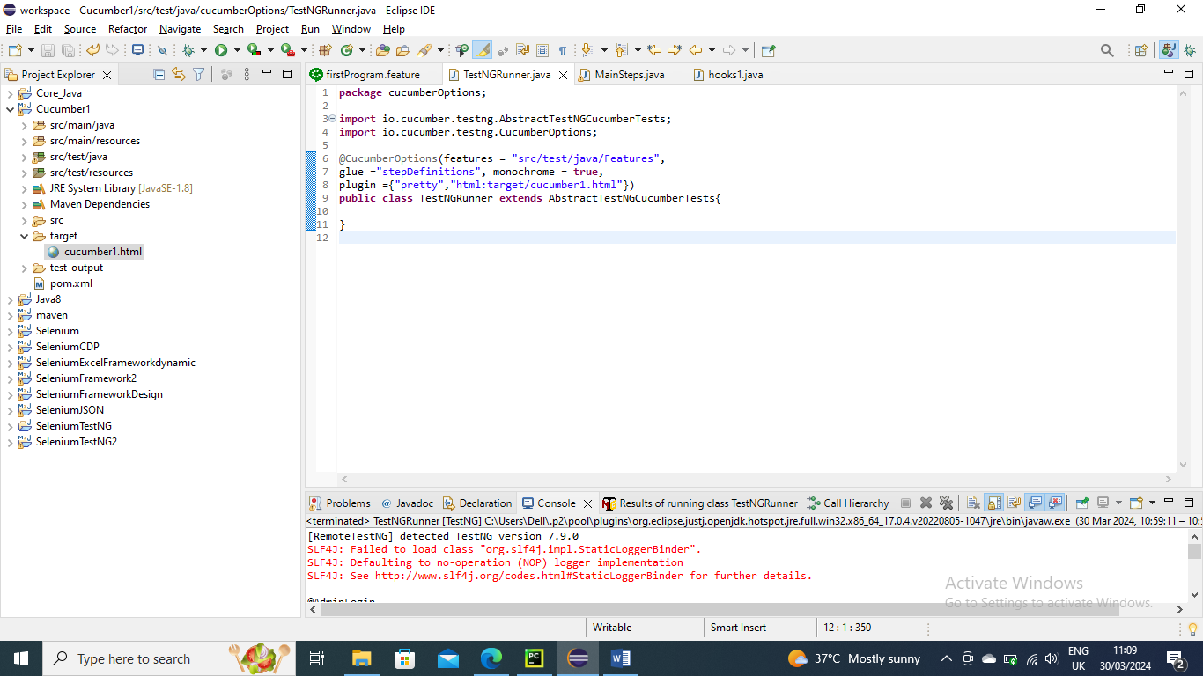

Below is the output……as you can see you can see all the details in html why it got failed

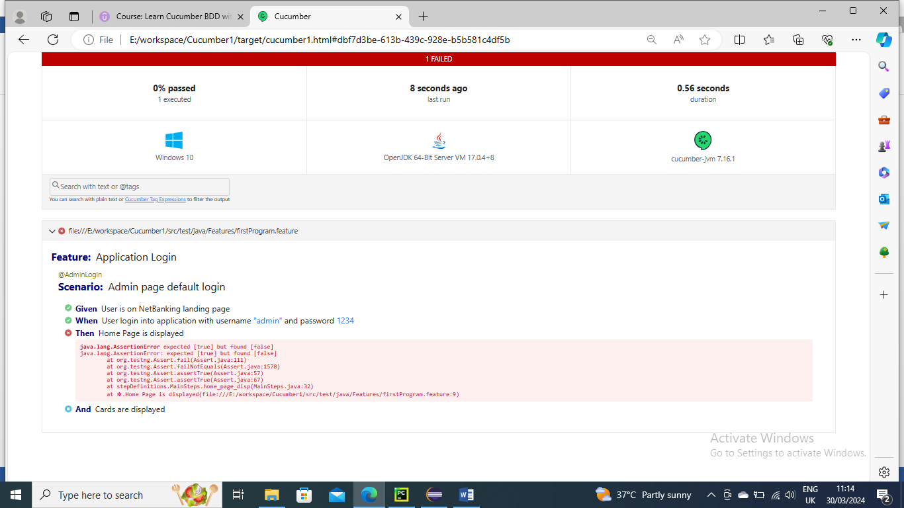

--------------------------------------------

If you want to have JSON report you can add that into in plugin as well to get json report

Note- I didn’t change any other program other than main program to add 3rd argument for JSON……………if you don’t want html you can remove that and place the JSON details in 2nd argument

And now the run this Main program

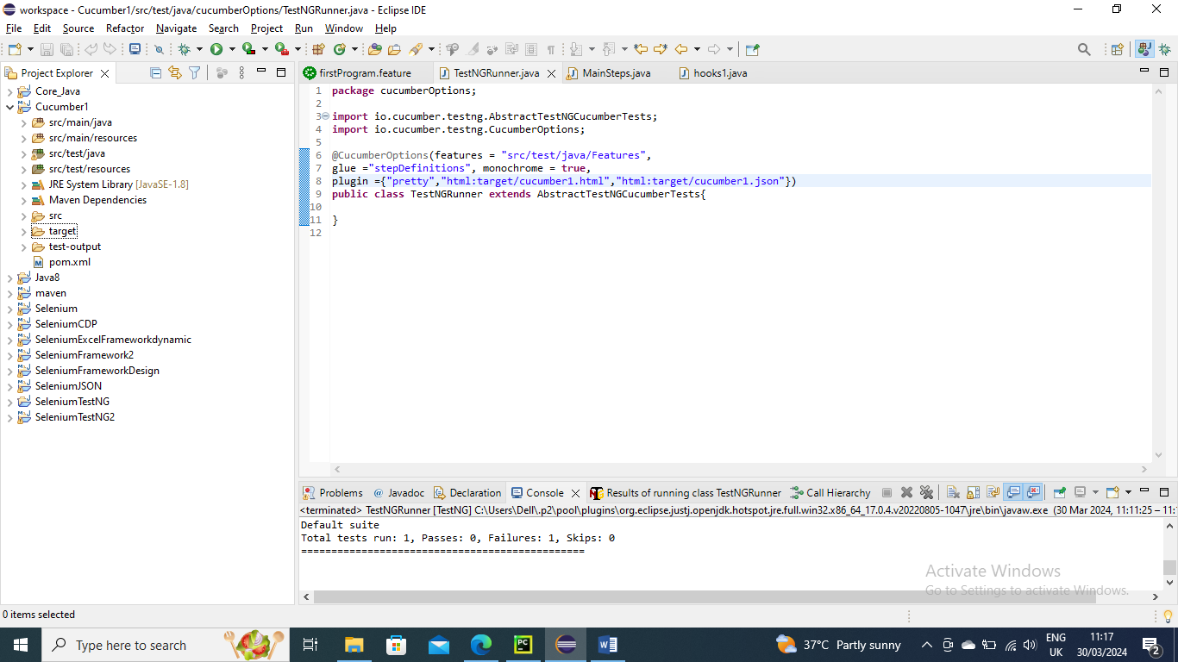

Below is the output you can see JSON report created in Target folder

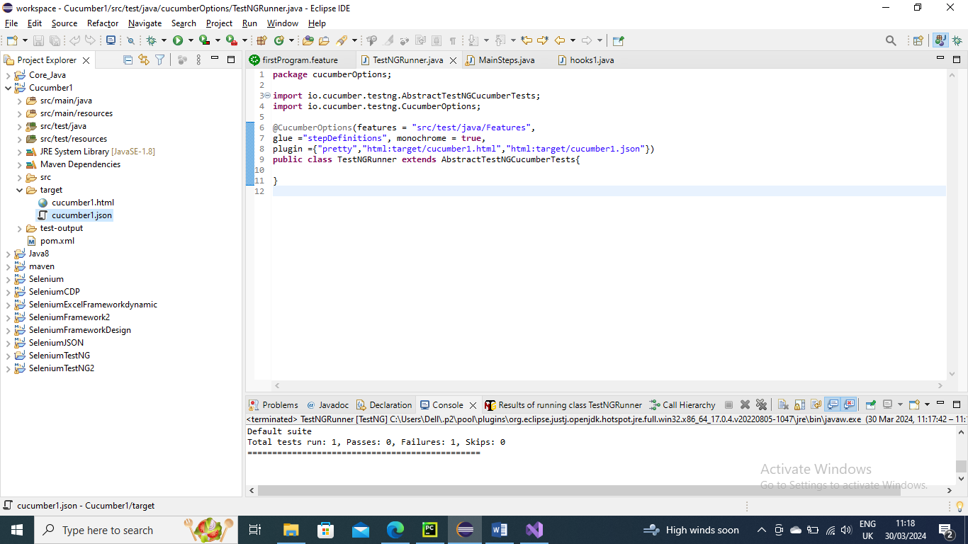

Now open the JSON file to see the output information

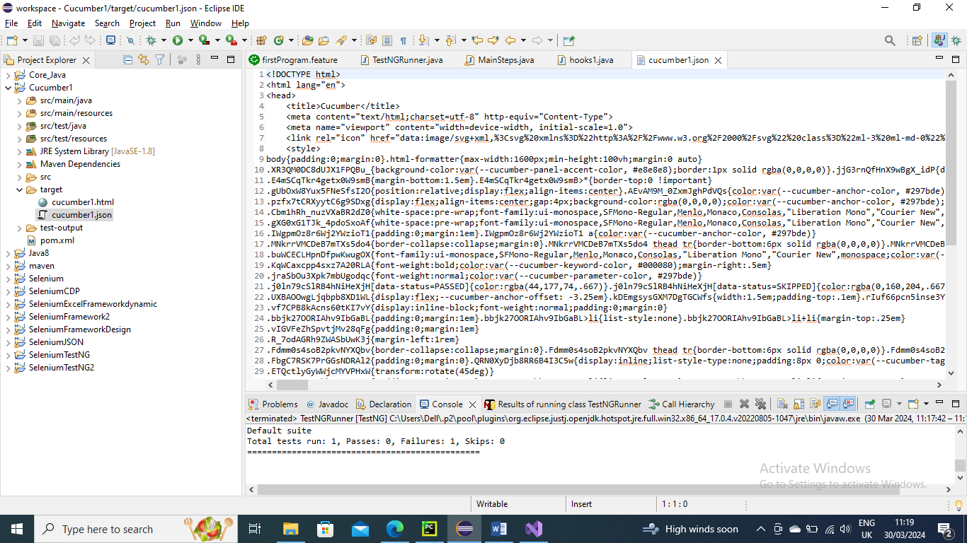

-----------------------------

You can have multiple feature file in same project……Which first will get picked up will be on alphabetic order

For example in below I have created another feature file asecondprogramfeature so that alphabetically it should be picked first

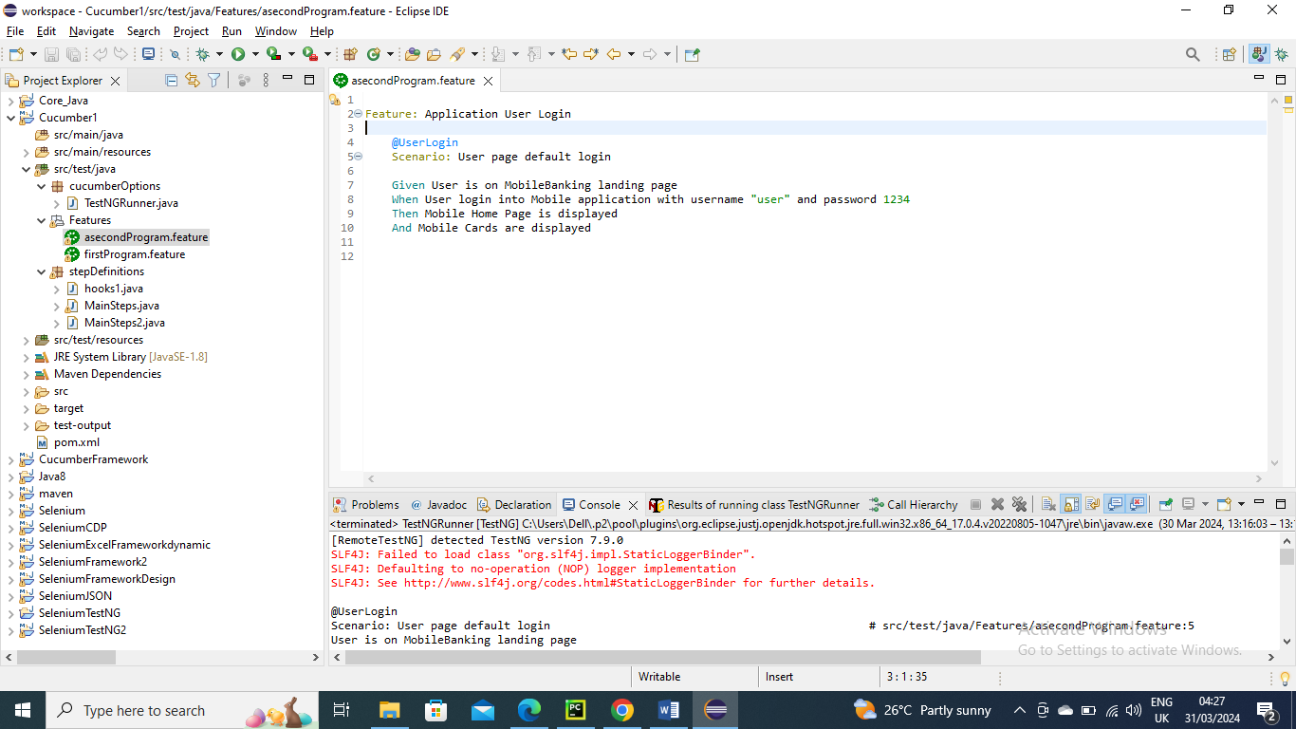

Now I need to create/declare these conditions so I create a new program in stepDefinitions and created in it…….You can also create in same existing program as well i.e. MainSteps

No changes in Main program and run it

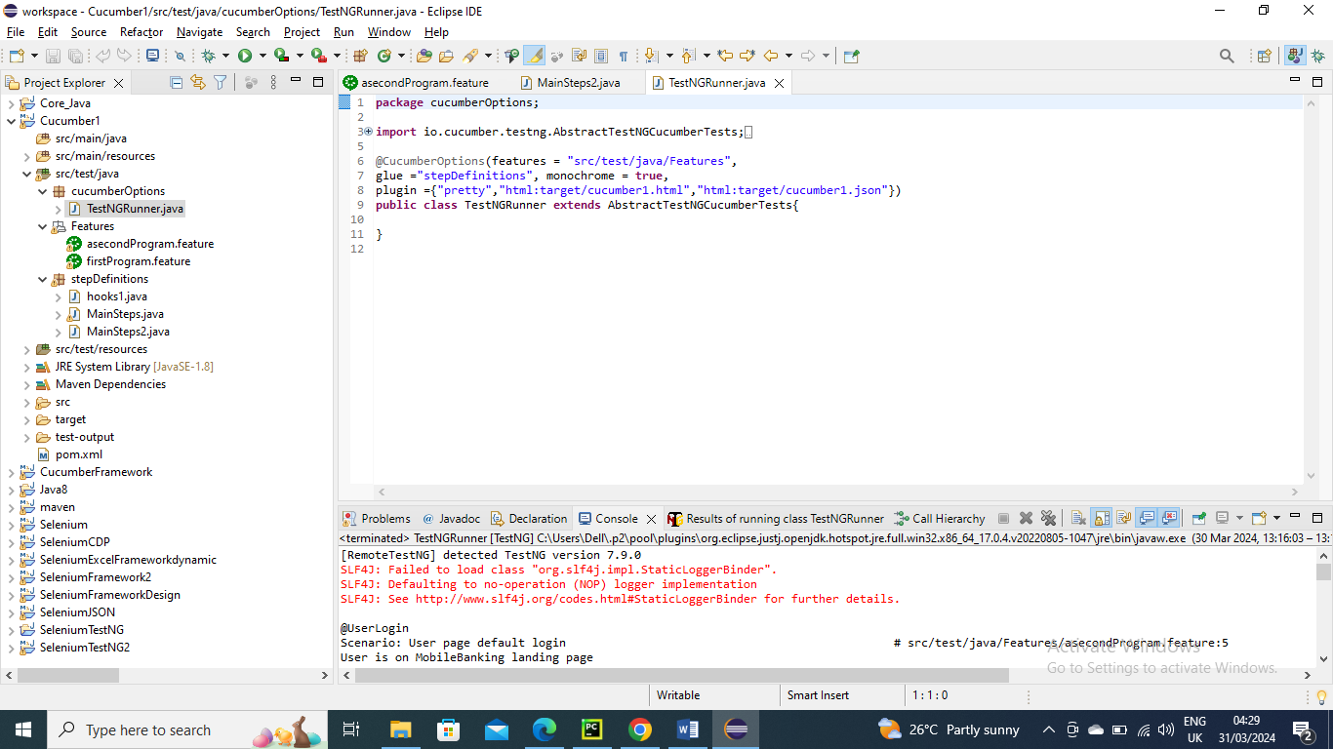

Below is the output...............As expected asecondfeature file conditions ran first and then firstprogram feature file

